## Dart

在 Dart 中，所有的項目都是物件 (Object)，包括函數 (Functions) 也是物件。

另外要提的是屬性名稱前面的_，在Dart並沒有private、public、public這些關鍵字，當你要使function或是變數為private時只需要在名稱前加上_即可，這樣能防止變數被其他地方存取。

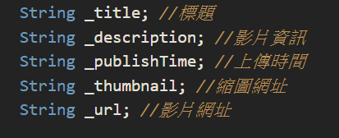

**型態**

Dart擁有**int**、**double**、**String**、**bool**等常見的變數型態  
也可以用「var」讓Dart來幫你決定。用 **var**在宣告賦值後就不能再賦予它其他型態的值了。

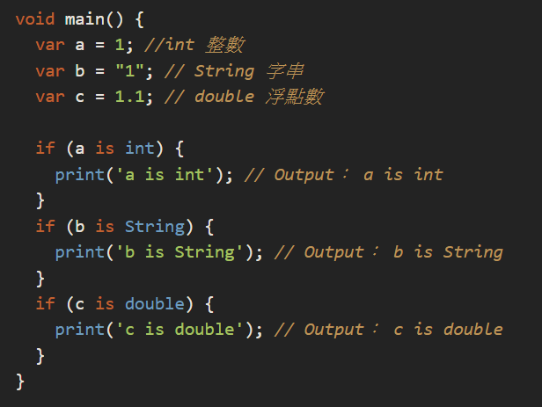

也可以用**dynamic**來做宣告，**dynamic**是所有物件的基礎類型，也就是說它可以代表任何物件。  
換句話來說，Dart的「dynamic」和JavaScript的「var」非常相似，可以隨時替換不同型態的值給變數。

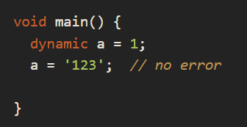

這是由於一開始並未給**變數a**初始值，因此**var**會給予**變數a** **dynamic**型態，所以就算替換了不同型態的值也不會報錯。雖然這次也是使用**var**來宣告，但卻可以替換成不同型態的值。

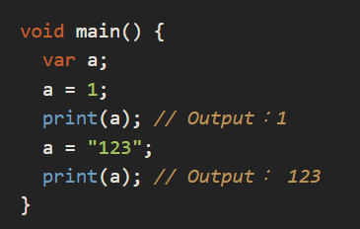

# var ，final 同樣也有類型推斷 (Inferred Type)的能力，如下例：

var item = 'This is a String';   
print(item.runtimeType); *// String*

final finalItem = 'final item';  
finalItem = 'New final item'; *//Compilation-error*

用關鍵字 final 宣告變數，**必須在宣告時就指定數值**，否則 IDE 將會編譯錯誤。

final emptyItem; *//Compilation-error*

### const const 是 compile-time 常數，意指這個數值是**恆久不變**的。

const maxValue = 1000;

如果需要在 class 裡面定義 const ，需加上 **static**，否則將會 compilation-error。  
Instance variables can only be final and not const  
static variables is **preferred to be const over final** because **const** declarations are **more hot-reload friendly** and can saves memory since **static variables are not meant to change** why not tell the computer that by using the const “indicator”?.

|  |  |
| --- | --- |
|  | class BlueSquare extends StatelessWidget { |
|  | final double size; |
|  |  |
|  | static const info = "I am a blue square"; |
|  | } |

The **const** and **final** are in fact **very similar** as they **both define values that should not change**. But **final** is more like the **less strict** form of const in that, it **holds values that should not change** but those values **can be unknown for a period of time** even after compilation, but **once it is known, it never changes**.

final response =  
 await http.get(Uri.parse(‘https://jsonplaceholder.typicode.com/albums/1'));

class TestConst{  
 static const VALUE = 1000;  
 }

const 除了可以定義常數之外，還可以建立常數。

var foo = const[];  
final bar = const[];  
const baz = []; *//等於 const[];*

foo[0] = 1; *// Cannot modify an unmodifiable list*foo = [1, 2]; *// OK*

bar[0] = 1; *// Cannot modify an unmodifiable list*bar = [1, 2] *//Compilation-error*

A constant constructor is a constructor which initializes all its final fields, and it is often denoted with a const in front of the constructor.  
  
If you don’t add the const keyword in front of the constructor, then even if it satisfies the conditions to be const, it will not be considered as such by Flutter and you can not initialize it with a const.   
  
Before we continue further, it’s worth noting that const is used for compile-time constants, like Strings, numbers, doubles and even Classes. Yes, classes.  
  
The actual use of the const keyword is to serve as an indicator that tells the compiler that, “for this variable, it will never change in the lifetime of this code, so create just one copy of it and where ever it is mentioned, just reference back to the one copy you already created and don’t create a new one.”  
  
The fact that it **saves memory** is not the only importance of **const** widgets. Because an object is marked as **constant**, flutter knows that in the case of a rebuild, it makes no sense to rebuild that object since “it should not have changed”. This is a **great performance boost** as once an object is built, in the lifetime of the app, it will remain the same, and that is just spectacular and improves even the **hot restart functionality** of flutter as it knows where and what to rebuild based on changes.

|  |  |
| --- | --- |
|  | class BlueSquare extends StatelessWidget { |
|  | final double size; |
|  |  |
|  | →→ const BlueSquare({Key? key, required this.size}) : super(key: key); |
|  |  |
|  | Widget build(BuildContext context) { |
|  | return Container( |
|  | height: size, |
|  | width: size, |
|  | color: Colors.blue, |
|  | ); |
|  | } |
|  | } |

And then we create objects as

const BlueSquare(size: 50);

# dynamic / Object dynamic 是關鍵字，Object 是類型。

dynamic dynamicItem;  
dynamicItem = 1; *// OK*dynamicItem = 'Dynamic Item'; *//OK*

Object objectItem;  
objectItem = 2; *// OK*objectItem = 'Object Item'; *// OK*

### dynamic 與 Object 有什麼差別呢？

* 關鍵字 dynamic 表示該變數**可以使用任意的類型**；當指定數值之後，Dart 編譯器會做類型推斷，該變數成為該類型，如上例為 String。
* 類型 Object 是所有類型的父類別，也就是說它**並不能使用子類別的方法**。如上例，變數的類型指定為 Object ，所有等號右邊的數值都會以 Object 儲存，所以 String 的 length 就無法使用。

dynamic dynamicItem = 'Dynamic Item';  
print(dynamicItem.length); *// 12*

Object objectItem = 'Object Item';  
print(objectItem.length); *// Compilation-Error*

**List**

定義list需要使用方括號[]，以在宣告的時候定義儲存值的型態，或是用**dynamic**來接受所有的型態。  
如果list內的值不想要被更動，在宣告時可以使用**const**關鍵字來把值固定，之後就無法對**List**做新增修改刪除了。

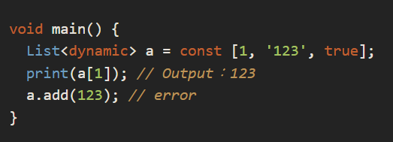

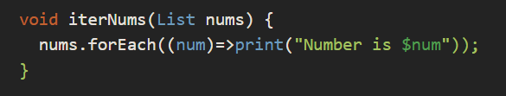

### 常用 List 類方法

* add(E element) : 新增一個項目。
* addAll(Iterable iterable)：附加帶入的 Iterable 所有項目。
* clear()：清除所有項目，List 的長度變為 0 。
* insert(int index, E element)：插入項目至 Index 。
* remove(Object? value)：移除第一個查到的項目。
* removeAt(int index)：移除索引值的項目。
* removeLast()：移除最後一個項目。
* shufflue()：隨機排列原 List。

**Map**

### **Map**是使用key-value的方式來儲存的資料型態，Map是使用大括號{}，以Key:Value的方式定義。 定義空 Map

* 使用大括弧直接定義

var emptyMap = {}; *//_InternalLinkedHashMap<dynamic, dynamic>*var emptyMap = <String, String>{}; *//_InternalLinkedHashMap<String, Stirng>*

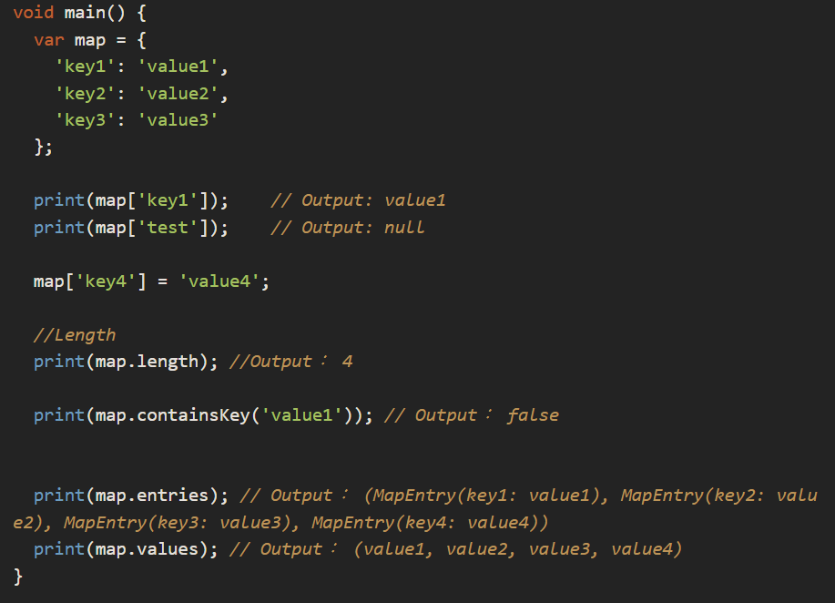

var capital = <String, String>{  
 'Taiwan':'Taipei',  
 'Japan':'Tokyo',  
 'USA':'Washington'  
};

print(capital.containsKey('Taiwan')); *// true*

print(capital.containsKey('China')); *// false*  
  
print(capital.containsValue('Tokyo')); *// true*  
print(capital.containsValue('Seoul')); *// false*capital.forEach((key, value) => { print("$key's capital is $value.") });   
// Taiwan's capital is Taipei.   
// Japan's capital is Tokyo.   
// USA's capital is Washington.

## Function

### 在Dart裡，function被視為物件，可以把function存成變數或是作為其他function的參數來使用。 非必要參數

定義函數時，可以將非必要參數使用中括弧包起來，呼叫函數時，就不一定需要帶入此參數。

void printIt(String name, int age, [String greeting]){

greeting ??= "Hello"; // if greeting = null, then assign value  
 print("$greeting, My name is $name, I'm $age.");  
}

void main(){  
 printIt('Andy', 35, 'Hey');  
 printIt('Jason', 40);  
}

*// Hey, My name is Andy, I'm 35.  
// Hello, My name is Jason, I'm 40.*

我們可以替**非必要參數**加上**預設值**。

* 加上預設值的方法：在變數名稱後方用等於指定預設值。

void printIt(String name, int age, [String greeting = "Hello"]){

print("$greeting, My name is $name, I'm $age.");

}

function也可以使用命名參數(Named parameters)  
使用時給予參數的順序並不影響結果，只要key和value對應正確即可。  
命名參數可以為空，也可以提供預設值，若沒提供則為null(如沒有提供month，month輸出就為null)

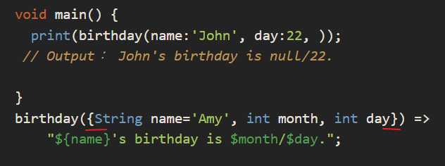

* 在呼叫的時候，就可以清楚地知道帶入的參數是什麼用途。
* 用大括弧定義參數，表示這些**參數是可選**的，**不一定需要輸入**，呼叫時，可以省略該參數。

void main(){  
 printIt(name:'Leo', age:30);  
}

void printIt({String name, int age}){  
 print("My name is $name, I'm $age.");  
}

但是，我們有時候是需要命名參數這項功能，不是要讓該參數成為可省略的，我們可以在參數前方加上註解 ＠required

### ＠required

在參數前方加上 ＠required ，當呼叫函數卻未帶入該參數時，編譯器會出現警告，如此，就可以避免忘記傳值的情況。

void printIt({@required String name, @required int age}){

print("My name is $name, I'm $age.");

}

### 加上預設值

我們亦可以在變數後方**加上等號指定預設值**。

# 型別測試運算子 (Type test operator)

1. as, is, !is

* as 範例：

假設有一個 Customer 類，接者有兩個類別分別實作 Customer 類，一是 VIPCustomer 含有兩個函數（buyAll(), buy()），另一個是 NormalCustomer 含有一個函數（buy()）。

*//as*

class Customer {}

class VIPCustomer extends Customer {

void buyAll(){}  
 void buy(){}  
}

class NormalCustomer extends Customer{  
 void buy(){}  
}

* 有一個函數 buySomething，是以 Customer 作為參數，裡面想呼叫 VIPCustomer 的 buyAll ，因你知道傳進來的一定是 VIPCustomer ，但是因為 Customer 類裡面並沒有包含 buyAll()，所以需要先用 `as 把 customer 轉型成 VIPCustomer 才可以呼叫其buyAll( ) 函數。

void buySomething(Customer customer){

(customer as VIPCustomer).buyAll();  
}

→ 不過這樣子寫，如果傳進來的不是 VIPCustomer，那就會發生 Exception。

* 可用 is 改寫

void buySomething(Customer customer){

if(customer is VIPCustomer){  
 customer.buyAll();  
 }  
}

### 發現什麼？

用 is 判斷後，該物件則自動轉型成期望物件，所以可以直接呼叫期望物件的函數。

void printIt({ @required String name = "Andy", @required int age = 30 }){  
 print("My name is $name, I'm $age.");  
}

### expr1 ?? expr2

⇒ 若 expr1 為 null ，則return expr2；反之，return expr1。

範例：有一函數判斷文字是否為空，若否則回傳該文字，否則回傳預設值。

void user(String user){

if(user != null){  
 print('user is $user');  
 }else{  
 print('user is root');  
 }  
}

* 將上例用條件表達式改寫

void user(String user){  
 final result = user ?? 'root';  
 print('user is $result');  
}

只需要一行，就能夠處理文字為空的情況。

??= ，非空指派運算子  
**null-coalescing operator** (**??**) to provide a default value.  
*bool indoorSeating =* hasIndoorSeating ?? true;

⇒ 若運算子左方的值為空 (null)，則使用右邊的值。

*factory* Restaurant.fromJson(Map<String, dynamic> data) {

// casting as a nullable String so we can do an explicit null check

*final* name = data['name'] as String?;

if (name == null) {

throw UnsupportedError('Invalid data: $data -> "name" is missing');

}

// casting as a nullable String so we can do an explicit null check

*final* cuisine = data['cuisine'] as String?;

if (cuisine == null) {

throw UnsupportedError('Invalid data: $data -> "cuisine" is missing');

}

*final* yearOpened = data['year_opened'] as int?;

// thanks to the if statements above, name and cuisine are guaranteed to be non-null here

return Restaurant(*name:* name, *cuisine:* cuisine, *yearOpened:* yearOpened);

}

我們可以將上面範例改寫為， 用 ??= 改寫，我們少了一個臨時變數。

void user(String user){

user ??= 'root';  
 print('user is $user');

}

# 串接符號 (Cascade notation)

### ..

串接符號可以用來在相同的物件中，連續執行運算。  
在 Kotlin 中，跟 apply{ } 具有相同的效果。  
例如，有一個 Student 類別，裡面有幾個屬性。

class Student{

var id;  
 var name;  
 var classRoomName;  
 var teacher;  
}

我們將 Student 類實例化，並設定屬性值。

var student = Student();

student.id = 1;  
student.name = 'Andy';  
student.classRoomName = '1A';  
student.teacher = 'Mandy';

* 用串聯符號改寫。

var student = Student()  
 ..name = 'Andy'  
 ..classRoomName = '1A'  
 ..id = 3  
 ..teacher = 'Mandy';

### 發現什麼？

1. 用串聯符號改寫可以不需要先將類別實例化，才設定屬性，減少了使用實例後變數。
2. 每一個串聯符號後方不需符號，直接換行。

也可以不換行，如下

var student = Student()..name = 'Andy'..classRoomName = '1A'..id = 3..teacher = 'Mandy';

串聯符號除了可以使用在屬性，還可以**應用在回傳值為 void 的函數**上，假如，類別裡面有回傳值為 void 的函數 (doSomething1, doSomething2) 。注意：只有回傳值為 void 的函數才能被串聯。

class Student{

var id;  
 var name;  
 var classRoomName;  
 var teacher;  
  
 void doSomething1(){ }  
 void doSomething2(){ }  
}我們也可以直接在串聯符號中直接呼叫。

var student = Student()  
 ..name = 'Andy'  
 ..classRoomName = '1A'  
 ..id = 3  
 ..teacher = 'Mandy'  
 ..doSomething1()  
 ..doSomething2();

if-else判斷式

有一個簡潔的寫法叫做三元運算子(Ternary)，三元運算子在Flutter也經常會使用到喔。  
三元運算子的語法為X = Condition ? A : B;  
翻譯成中文就是，若Condition為true，X = A  
        若Condition為false，X = B  
註：A和B也可以代入function來使用

## for迴圈

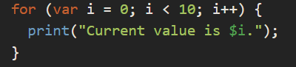

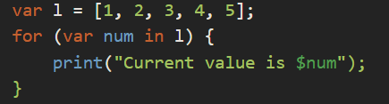

var list = ['Tiger', 'Lion', 'Eagle'];

for(var item in list){  
 print(item);  
}

## 例外處理

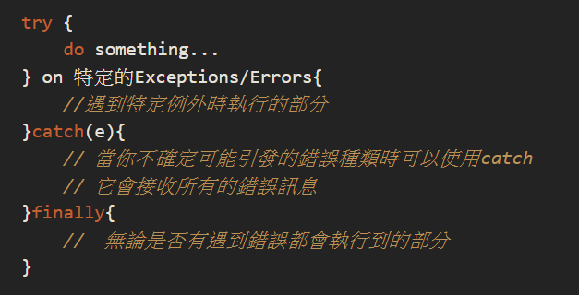

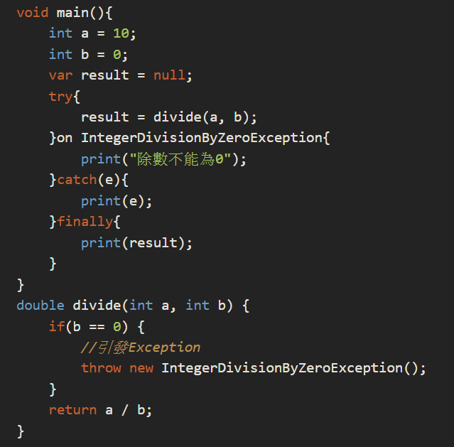

### num

enum 是一種型別，用於自定義 type，若用在 switch 上，IDE 會自動告訴我們有哪一個 enum 尚未考慮到。

* 如何定義 enum?

用關鍵字 enum 加上 enum 名稱，用大括弧定義所有的情況。

範例：有一個 enum 型別，名稱為 NetworkState。我們定義三種情況：1. online，2. offline, 3. airplane_mode。

enum NetworkState{online, offline, airplane_mode}

* 如何使用 switch case 搭配 enum

void checkNetworkState(NetworkState networkState){

switch(networkState){  
 case online:  
 print('Online');  
 break;  
 case offline:  
 print('Offline');  
 break;  
 case airplane_mode;  
 print('Airplane Mode');  
 break;  
 }  
}

# assert

在開發中，我們有可能會需要確定某些地方的值是否如我們預期，我們可以用關鍵字 assert。

例如：我們希望該函數 showName 沒有空值傳進來，我們可以在函數裡面加上 assert，當在 debug 模式發生傳入 showName 的值為空時，此時就會發生錯誤。

void showName(String name){  
 assert(name !=null );  
 print('$name')  
}

# 例外 (Exception)

在 Dart 中，如果發生例外卻沒有去處理，那麼就會暫停 Isolate ，且程式被中斷。

Dart 的例外是「未經處理的例外 (Unchecked exception)」：Dart 不會強迫處理每一個會拋出異常函數。與之對立的是 Java：在當呼叫的函數會拋出例外，那麼使用該函數的類或是其子類別，一定要將例外捕捉。為什麼 Dart 是未經檢查的例外，原因在於，它不希望我們用了一大堆 try-catch 去捕捉錯誤，只要針對一定要捕捉的去捕捉，因為以前在開發 Java 時，很常遇到某個函數會拋出例外，我們用 try-catch 去捕捉例外，但是在 catch 裡面卻又沒有做任何事情，那麼原本應該發生錯誤通知使用者的，變成沒通知，然後可能帶者錯誤的狀態繼續往下。所以為什麼 Kotlin、Dart 都改成未經檢查的例外。

雖然 Dart 不會強迫處理例外，可以讓程式碼乾淨許多，但是函數若發生例外時，程式還是會中斷。

try-catch-finally 不一定需要三個都使用，我們可以只用其中兩個：try-catch 或是 try-finally，這完全取決於使用情境。

自行實作例外、錯誤。

範例：

class MyError extends Error{

final String message;  
 MyError(this.message);

@override  
 String toString() {  
 return 'MyError: $message';  
 }

}

測試：

void main(){  
 throw MyError('This is my customized error');  
}  
 *//Unhandled exception:  
//MyError: 'This is my customized error'*

**Class**

Flutter只能有一個**Unnamed Constructor**，而不是像Java具有多載的特性可以定義擁有相同名字的建構子。但Flutter擁有易讀性更高的**Name Constructor**，來看下面的例子吧。

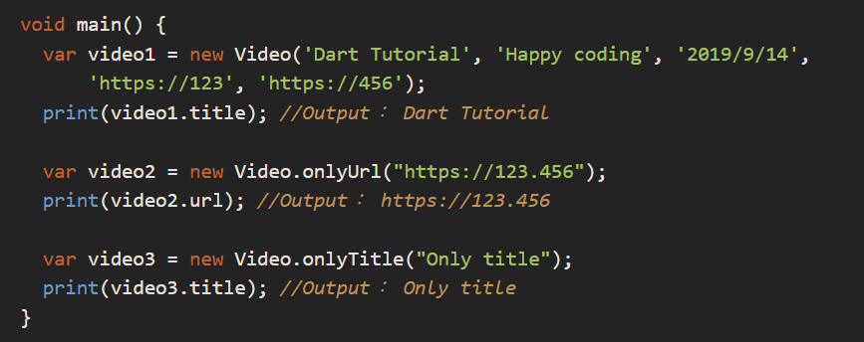

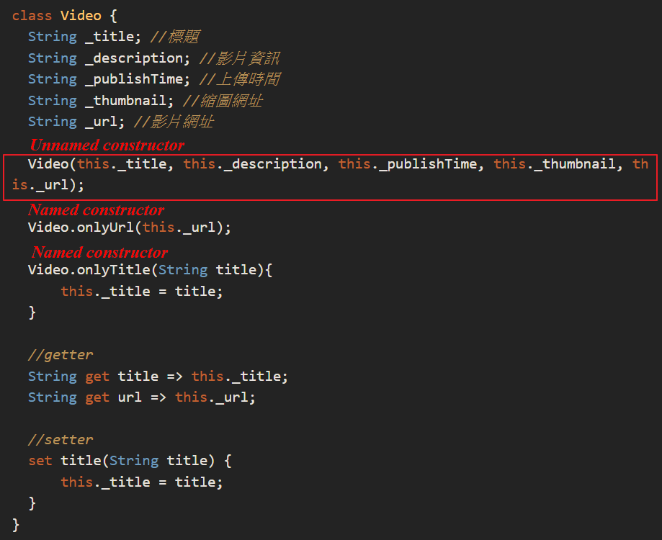

在點前方加上一個問號 (**?.**)，代表非 null 時，才參考，**否則就跳過**。

void main(){

Student student;

student?.name;  
}

範例：替 Student 類加上建構式。

class Student{  
 final String name;  
 final int age;

Student(this.name, this.age);

void greeting(){  
 print('Hello, my name is $name');  
 }  
}

### 發現什麼？

1. 屬性前方加上 final：代表屬性是由建構式傳入，在**類別內無法被修改**。如此可以確保我們的屬性不會因為程式而變動。

# **具名建構式 (Named Constructors)**

class Student{  
 String name;  
 int age;

Student(this.name, this.age);

Student.first_grade(String name){  
 this.name = name;  
 this.age = 8;  
 }  
}

### 發現什麼？

1. 移除 final 修飾，因為建立一個新的具名建構式，所以原本的建構式產生時就不會將屬性帶入，那麼該 final 的屬性就會為 null 。這是不被允許的。

在上方的範例中，具名建構式設定屬性值的動作是在大括弧內進行，我們可以將大括弧改為直接呼叫預設建構式。

class Student{

String name;  
 int age;

Student(this.name, this.age);  
 Student.first_grade(String name) : this(name, 8);  
}

### 發現什麼？

我們在具名建構式後方加上冒號以及關鍵字 this，這表示要呼叫這個類別裡的建構式。  
接者，我們將具名建構式的**引數**直接傳給預設建構式，再將數字 8 填入第二個欄位。  
這樣一來，我們使用具名建構式之後，它就會將值傳給預設建構式，來達到一樣的效果。

# 工廠建構式 (Factory constructors)

A factory constructor is a good choice for JSON parsing as it lets us do some work (**create variables, perform some validation**) **before returning the result**. This is not possible with regular (generative) constructors.  
  
*factory* Restaurant.fromJson(Map<String, dynamic> data) {

*final* name = data['name'] as String; // explicitly cast to String

*final* cuisine = data['cuisine'] as String;

return Restaurant(*name:* name, *cuisine:* cuisine);

}

在工廠模式中，我們可以產生一個類別的實例化。

工廠模式的關鍵字 factory。

class Student{

String name;  
 int age;

Student(this.name, this.age);

factory Student.first_grade(String name){  
 return Student(name, 8);  
 }  
}

# 常量建構式 (Constant constructors)

上面的範例，在我們每次建立實例的時候，都會指向記憶體的某一塊區域。雖然帶入的引數相同，在執行時，都會被指向不同的記憶體區塊。

有時候，我們希望帶入的引數相同，在建立類別實例時，這些類別實例會被指向在同一個記憶體位置上。

這時候我們可以用關鍵字 const 來定義建構式。

範例：將 Student 的建構式以 const 修飾。

class Student{

final String name;  
 final int age;

const Student(this.name, this.age);  
}

把它實例化看看，並利用 identical() 檢查兩個物件是否相同。

void main(){

var student1 = const Student('Alex', 10);  
 var student2 = const Student('Alex', 10);

var isSame = identical(student1, student2);

print(isSame); *//true*  
}

identical 的說明如下：Check whether two references are to the same object.

Dart 提供了四種不同的建構式：預設建構式、具名建構式、工廠建構式以及常量建構式。每一種建構式都有不同的使用情境。

**預設建構式**是一個類的最基本建構式。  
**具名建構式**可以用在一個類的延伸用法，譬如說某些屬性是固定值。  
**工廠建構式**在每一次呼叫的時候，都會建立一個新的實例，我很常使用在收到 Http request 之後，解析 Json Object 並實例化物件。  
**常量建構式**用在如果需要在相同的引數下指向相同的記憶體位置時。(表示是完全相同的物件，不是只有屬性相同)

# 可見性 (Visibility)

預設類別中的每一個屬性，函數都是可以被外部呼叫者看到的。如果某些屬性與函數僅在類別內部使用，那麼必須要將屬性或是方法名稱前方加上下底線。

class SampleClass{

String value1;  
 String value2;  
  
 String _privateValue1;  
 int _privateValue2;

void doSomething1(){ }  
 void doSomething2(){ }  
  
 void _privateDoSomething(){ }}

如此一來，外部的呼叫者就無法呼叫**函數**或**方法名稱**開頭是為**底線**的物件。

# **Mixin**的機制 Mixin 有利於代碼重用以及避免了多繼承的複雜，是帶有實作的 interface。 Why mixin?

extends 只能繼承一個類別，而 with 可以引入多個 mixin  
mixin就是含有實作的 interface，利用 mixin 我們可以將依賴反轉。  
一個類別可以用 with 引入多個 mixin 。  
關鍵字 on 可以限制 mixin 只能提供給特定的類別使用。

能讓你的class使用其他class的功能，卻不用成為它的子類。而且能一次Mixin多個class，使用起來比繼承更有彈性。  
使用Mixin的關鍵字為with

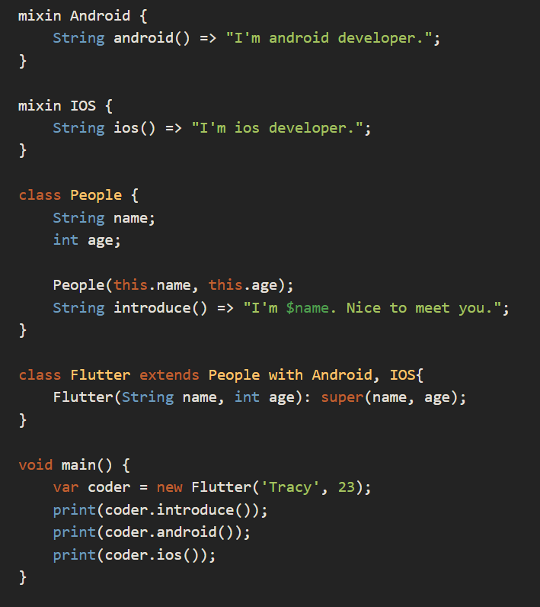

定義一個Flutter class讓它繼承People並mixin新增的Android IOS這兩個mixin class。  
如此一來我們實體化的物件coder就可以使用他們三個class的功能。

並將 AquaMan 類改為：

class AquaMan extends SuperHero with UnderWater{}

* AquaMan 既屬於 SuperHero 類，也包含 UnderWater。

有一個 Animal 的類別，我們想增加一個 UnderWaterAnimal 類，我們就可以直接使用前面所定義的 mixin UnderWater

class Animal with UnderWater{}

* 如果要限制 mixin 只能給特定的類使用，使用關鍵字 on 。 那麼 UnderWater 就只能被 SuperHero 類或子類別引入了。

mixin UnderWater on SuperHero{

void waterBreath(){  
 print('Can breath in water');  
 }  
}

### 靜態變數的初始化

由上面的範例得知，當靜態變數未設定初始值，則值為 null。

修改一下上面的範例，讓該靜態變數是由外部取得。我們來看一下靜態變數的初始化。

class Log {

static String tag = TAG('Dart').name;  
 String message;

Log(this.message);

void sendMessage(){  
 *//send message* print('message sent');  
 }  
}

class TAG{  
 String name;  
 TAG(this.name){  
 print('Tag is $name');  
 }  
}

void main(){

final tag1 = Log.tag; *//Tag is Dart* print(tag1); *//Dart*  
 final tag2 = Log.tag;  
 print(tag2); *//Dart*  
 Log.tag = 'Dart2';  
 print(Log.tag); *//Dart2*

}

靜態變數只有在第一次使用的時候進行初始化 (run the constructor)，之後每次呼叫，都只是從記憶體取出該值而已。

覆寫靜態變數(assign value to static variable)之後，每次取值都是新的值。

# 頂層函數 (top-level functions) 、頂層變數 (top-level variables)、頂層常數 (top-level constants)

定義頂層變數、頂層常數的方式也很簡單。將原本定義在類別內的靜態變數、靜態常數移出類別，並將 static 關鍵字移除。

const bool isDebug = true;  
String tag= TAG('Dart').name;

void sendMessage(Log log){  
 *//send message* print('[$tag]:${log.message}');  
}

class Log {  
 String message;  
 Log(this.message);  
}

如此，類別內就只剩下非靜態的屬性、方法。變得單純許多。

靜態變數、靜態方法在程式語言中是一定會存在的項目，使用靜態項目常常被質疑違反了物件導向的設計。因為不需要將類別實例化就可以使用該變數或方法。本篇文章不討論使用的好處與壞處，純粹只是介紹靜態項目的用法。

在 Effective Dart 提到，避免建立一個類別只存在一個靜態項目，若是有這樣使用靜態項目的需求，可以改用頂層函數、頂層變數、頂層常數來替代。  
Avoid defining a class that contains only static members.

# 泛型

* 將類型名稱後面加上角括弧，並加上泛型型別的識別字母 T。

abstract class Cache<T> {

T getByKey(String key);  
 void setByKey(String key, T value);  
}

其中，Ｔ為替代類型，作為開發人員稍後定義的型別。

var names = List<String>();  
names.addAll(['Seth', 'Kathy', 'Lars']);  
print(names is List<String>); *//true*

# 限制泛型型別

用泛型設計時，有些時候並不想設計給全部的型別使用，只想開放給某類別及其子類別使用使用關鍵字 extends 將泛型型別繼承某類別，那麼該類別就只能使用某類別或其子類別。

class Foo<T extends SomeBaseClass> {  
  
 *// Implementation goes here...* String toString() => "Instance of 'Foo<$T>'";  
}  
  
class Extender extends SomeBaseClass {...}

我們定義了泛型類別 Foo ，並且限制它的泛型型別為 SomeBaseClass ，所以 Foo 類別可以接受 SomeBaseClass 及其子類別 Extender 。

var someBaseClassFoo = Foo<SomeBaseClass>(); *//OK*var extenderFoo = Foo<Extender>(); *//OK*

沒有使用角括弧指定型別也可以：

var foo = Foo();  
print(foo); *// Instance of 'Foo<SomeBaseClass>'*

但是，使用其他型別就不被允許

var foo = Foo<Object>(); *//Error*

# 泛型函數

泛型除了可以用在類別之外，還可以用在函數上。

定義函數的語法如下：

return_type function_name(arguments){}

我們將回傳型別 return_type 改為Ｔ，並且在函數名稱後面用<>定義**泛型的型別**。

範例：

T first<T>(List<T> ts) {

*// Do some initial work or error checking, then...* T tmp = ts[0];

*// Do some additional checking or processing...* return tmp;

}

# Callable Class

Dart 提供了一個特別的方法，如果類別裡面有一函數的名稱為 call ，那麼該函數則不需要名稱就可以呼叫。

class Logger{

String message;  
 Logger(this.message);

void call(){  
 print('Sending message: $message');  
 }  
}

void main(){

var logger = Logger('This is sample log');  
 logger();  
}

*//This is sample log*

這樣一來，便可以把類別轉換成可以呼叫的樣子。(A class can be called like a function)

當然，我們也是可以用 call() 來呼叫

void main(){

var logger = Logger('This is sample log');  
 logger.call();  
}

*//This is sample log*

### 這樣做有什麼好處呢？

有些函數的呼叫需要輸入不同的參數，根據不同的參數，我們可以得到不同的結果。  
如上面的範例，我們將參數轉成類別的屬性，當呼叫類別的 call() 時，就可以直接取用。

舉一個 Flutter 的範例：

有一個類別，專門用來儲存圖片的位置，在該類別裡面包含了一個 call() 函數，我們可以直接呼叫將圖片的位置轉換成圖片。

class DisplayImage{

String imagePath;  
 String(this.imagePath);

Image call(){  
 return Image.asset(path, fit: BoxFit.cover);  
 }  
}

* 只要這樣呼叫，就可以將圖片位置轉為 Image Widget。

DisplayImage('image path')();

* 看起來就像是呼叫一個函數，且因為 DisplayImage 的命名，使用者直覺就會認為這樣就可以產生出一個 Image。

假設沒有使用 call() 函數：

class DisplayImage{

String imagePath;  
 String(this.imagePath);

Image toImageWidget(){  
 return Image.asset(path, fit: BoxFit.cover);  
 }  
}

DisplayImage('image path').toImageWidget();

* 最後還需要呼叫 toImageWidget() 來將圖片路徑轉成 Image Widget，看起來比較冗長一點。

### 使用 Callable Class 需注意的地方

* 一個類別只有一個 call() 方法，但是除了 call() 之外，還是可以使用其他的方法名稱，只不過就沒有辦法不使用函數名稱來呼叫。
* call() 函數也可以帶參數。

class Logger{

void call(String message){  
 print('Sending message: $message');  
 }  
}

* BTW，也可以將上例改為頂層函數。

# 小記

Callable class 讓我們可以思考的是，類別中的哪一個函數可以被放在 call() 函數中。我認為 call() 函數放的是這個類別主要的工作。當呼叫者呼叫時，就可以清楚知道這個類別的主要工作是什麼。不需要多餘的函數名稱來誤導呼叫者。

那麼，如果類別裡只有一個函數，該用頂層函數 (top-level function) 還是 Callable class 呢？如果函數的工作需要跟類別的屬性有關係，用 Callable class 比較適合；反之，可以使用頂層函數。不過這個答案沒有絕對，完全取決於程式設計方向。

在 Dart 中，異步工作分為兩種：Future、 Stream 。

Future 是用在結果會在未來完成的情況，而 Stream 是用在資料流的情況。

針對異步的工作 Dart 提供了關鍵字 async 以及 await 來處理它。

Future  
Future 是針對耗時的工作，在工作完成時才回傳結果。並且可以利用 async 關鍵字建立異步函數，並在該函數使用await 關鍵字來等待 Future的回傳值。  
  
Future 表示會回傳是的值**可能會經過一些運算時間**，可能會需要多一些時間等待。有時候不見得是本機端很忙需要等待，網路的請求常常也會需要一些時間，所以在網路的應用上很常見到 Future 。

Future 的**結果會有兩種**，一種是**正常**的結果，另一種是**錯誤**的結果。我們可以用 then 來處理 Future 函數的正常結果，用 catchError 處理異常的結果。

在 Dart/Flutter 中，有許多 API 都是以 Future 來處理資料，例如 Http 請求 (Http request)、SharedPreference ...

在 Future 類別中，包含了幾個常用的靜態函數，方便我們直接建立一個 Future 。

### Future.value

Future<int> futureWait(){

return Future.value(10);

}

void main(){

futureWait()  
 .then((value)=>print(value)); *//10*  
}

* 將欲回傳的值填在 Future.value 中，該數值就會以 Future 的形式回傳。

### 將普通的數值轉成 Future 有什麼好處呢？

Future 類別包含了幾個函數，我們可以直接串接在 Future 之後。

如上方範例的 then ：

* then(value) ：在 Future 的數值回傳之後，就可以在 then 裡面使用這個數值，如 print(value) 。
* whenComplete() ：當 Future 完成之後，最後就會呼叫到 whenComplete 。

void main(){

futureWait()  
 .then((value) => print(value)) *//10*  
 .whenComplete(()=> print('done')); *//done*  
}

### Future.delayed

在測試 Future 時， Future.delayed 是最方便的一個函數。

在 Future.delayed 中帶入一個 Duration ，時間到了之後就會執行 Future 內的函數。

Future<String> futureDelayed(){  
 return Future.delayed(Duration(seconds: 1), () => 'Delay 1 second');  
}

void main(){  
 futureDelayed().then((value) => print(value));  
}

*//Delay 1 second*

* 如上面的範例，在執行 Future.delayed 函數之後，在一秒之後就回傳值了。我們同樣可以利用 then 將數值列印出來。

### Future.error

除了正確的資料外，當錯誤發生時，我們也可以用 Future 將錯誤捕捉起來。 Future.error 可以發出一個 Future 的 錯誤。

Future<String> futureError(){  
 return Future.error('error message');  
}

void main(){  
 futureError().catchError((error) => print(error));  
}

*//error message*

* 這邊是利用 Future類別的 catchError 函數來捕捉。

# Async/Await 關鍵字

前面提到，Dart 是用 async 以及 await 關鍵字來處理異步。  
異步，表示**完成的時間不一樣**，如果需要在**同一個函數**中進行**有順序的異步函數呼叫**。可以使用async 以及 await 關鍵字。

利用 async 將函數**宣告成異步函數**。用 await 決定要**等待哪一個函數**。  
在 async 函數中，可以使用多個 await。使用 await 一定要在 async 函數中。

那麼要如何使用呢？

呼叫異步函數的時候，每一個異步函數回傳的時間都不一樣，如果我們需要等待異步函數的回傳值才繼續，我們就可以使用 async 以及 await 關鍵字。

例如：  
假設有兩個 Future 函數，一個需要花費2秒回傳10，另一個直接回傳 true。

void testFutureMethod(){  
 futureMethod1().then((value)=> print(value));  
 futureMethod2().then((value) => print(value));  
}

Future<int> futureMethod1(){  
 return Future.delayed(Duration(seconds: 2), ()=>100);  
}

Future<bool> futureMethod2(){  
 return Future.value(true);  
}

* 我們嘗試呼叫看看

void main(){

testFutureMethod();  
}

*//true*...2 second...  
*//100*

結果會先傳出方法2的回傳值 true，接者才是方法1 的 100。

因為**異步沒有順序**，會根據完成的順序來回傳。

### 使用 async 以及 await

將 testFutureMethod 函數加上 async 以及 await 關鍵字。

async ：用來表示**該函數是異步函數**。  
await ：用來表示**要等待異步函數完成**。

void testFutureMethod() async{  
 await futureMethod1().then((value)=> print(value));  
 await futureMethod2().then((value) => print(value));  
}

void main(){  
 testFutureMethod();  
}

...2 second...  
*//100  
//true*

* 結果變成經過2 秒之後，才顯示第一個方法的回傳值，接者才是第二個方法的回傳值。
* 異步函數的順序因為 async 以及 await 關鍵字變得有順序了。

## Async

Future、async、await  
**Future**：Future是一個class，他用來表示非同步操作的結果，並且擁有兩個狀態，完成(completed)與未完成(uncompleted)  
  
**async**：async是一個關鍵字，是用於區分function是同步或是不同步，使用方法是在定義function時加上async  
  
**await**：只能在非同步function中才能使用await，用來等待非同步工作的完成結果，使用await有助於程式碼的易讀性

模擬非同步:

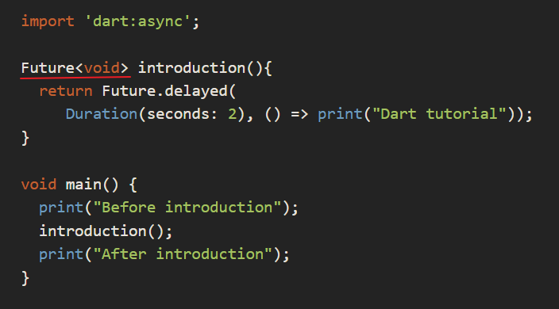

輸出的順序為"Before introduction" -> "After introduction" -> "Dart tutorial"  
確實執行introduction()不會讓程式卡住而是先往下執行，當完成後才又回去處理。

使用await的效果

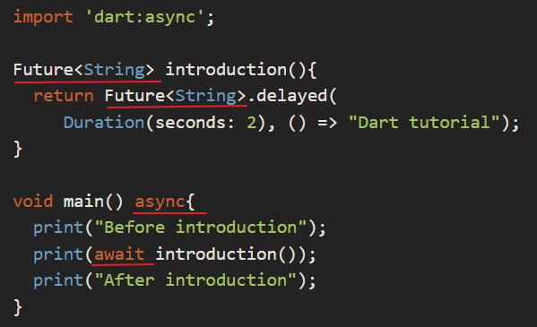

"Before introduction" -> "Dart tutorial" -> "After introduction"

證明使用await，程式會等待introduction執行完成取得回傳值才繼續執行下去。

## 擴充方法 (Extension method)

* extension 的語法如下

extension name on Type {  
 *//define method*}

例如：

extension IntegerParse on String {  
 int toInt(){  
 return int.parse(this);  
 }  
}

我們就可以直接在字串上使用 toInt() 函數。

var value = '20'.toInt();  
print(value); *//20*print(value.runtimeType); *//int*

介紹到這邊，你可能發現一件事，我們在 extension 後方加上的名稱並沒有使用到。

我們可以將上方的範例改寫為：

var value = IntegerParse('20').toInt();

* 將數值用 extension 定義的名稱包起來，就表示用這個擴充函數來操作。

### 擴充函數命名衝突

當不同的擴充函數定義了相同的方法，此時就可以有效區隔是哪一個擴充函數。

例如：

有另一個擴充函數 (IntegerParse2)，在使用 toInt() 時，有包含例外處理。由上方的範例更可以發現，我們可以在我們自己定義的擴充函數加上一些例外處理，將例外處理封裝在函數裡，外面的呼叫者就不需要自行處理。

extension IntegerParse on String {

int toInt(){  
 return int.parse(this);  
 }  
}

extension IntegerParse2 on String {  
 int toInt(){  
 var value = -1;  
 try{  
 value = int.parse(this);  
 }catch(e){

}

return value;  
 }  
}

Equatable   
將 Battery 類別繼承 Equatable 類，修改如下：

import 'package:equatable/equatable.dart';

class Battery extends Equatable{  
 final int powerLevel;  
 final String serialNo;  
 Battery(this.serialNo,[this.powerLevel]);

bool isFullPower(){  
 return powerLevel == 100;  
 }

factory Battery.fromJson(Map<String, dynamic>jsonMap) {  
 return Battery(jsonMap['serialNo'], jsonMap['powerLevel']);  
 }

@override  
 List<Object> get props =>[serialNo, powerLevel];  
}

1. 類別的屬性需改為 final ，因為 Equatable 有不可變屬性的註解(@immutable)。
2. 實作 **props** 函數，裡面填入**需要比較的屬性**。

* 我希望能夠利用單元測試測試這個函式是否正確運行，測試代碼如下：

void main(){

Battery battery;

group('fromJson', (){  
 final json = {'serialNo':'fake_serialno', 'powerLevel':50};  
 setUp((){  
 battery = Battery('fake_serialno', 50);  
 });

test('should return Battery when json is correct', (){  
 final result = Battery.fromJson(json);  
 expect(result, battery);  
 });  
 });  
}

* 可以看到我在 setUp 函數裡面定義了一個預期的 Battery 物件，序號為：fake_serialno，電量為：50。
* 在下方的測試，將一組 Json 物件傳入至 Battery.fromJson 中。

**StatelessWidget VS StatefulWidget  
StatelessWidget will build only once.  
StatefulWidget will build as long as setState() is executed.**

**什麼是 StatelessWidget？**

* 無狀態的元件，通常是純畫面。 (it will build only once!)

**建構子**  
  
1. 給予預設值 (可以傳參數，也可以不傳)

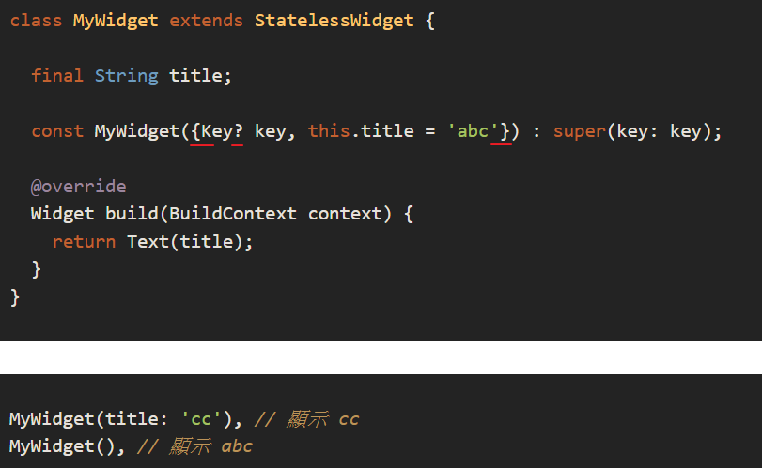

1. Required（被要求一定要傳參數）

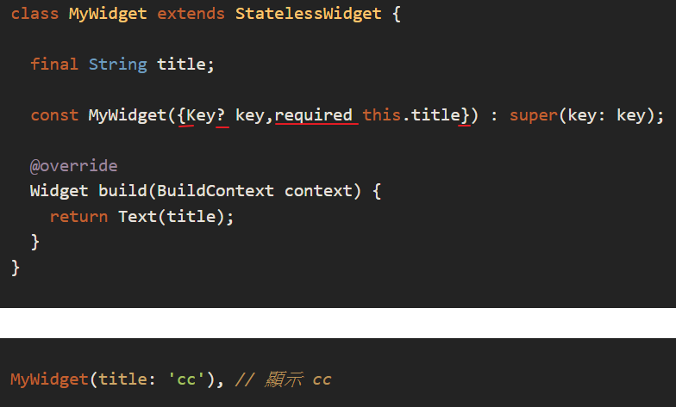

1. 私有化的參數

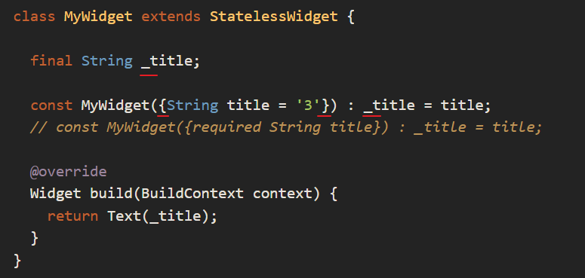

# 什麼是 StatefulWidget？ (it will build many times as long as the state is changed.)

* 他是一個具備 State（狀態）的元件，裡面所有可變狀態的子元件的狀態都會保留在 Staatefulwidget 所創立的 State 裡面。
* 目的：可以用來更新畫面，當你的畫面需要變動的話，你可能就須使用 stateFulWidget。

1. **createState**()

* 當你創建一個 statefulWidget 的時候，會看到一個 createState()，這邊他就是開始建立狀態。

1. **mounted is true**

* 底層的 flutter 會將 mounted 設定為 true，這代表他已經將 state 分配給你的子元件了。
* 你可以在 mounted == true 的情況下使用 setState() 來更新畫面。因為這個參數是用來確保 State 存在 setState()，也就是說，在 mounted == true 的情況才可以使用 setState()

1. **initState**()

* 只會調用一次，初始化，並要求要有 super.initState()。
* 這邊可以用來初始化一些參數、controlle 的 listener、stream.listen() 等等..
* 子元件依賴於更新的 InheritedWidget 會被調用。
* **注意**：initState 的 function 不一定會在全部執行完成才會觸發這個方法，有的時候 didChangeDependencies 被觸發時， initState() 裡面的方法還未全部執行完成。

1. **build**()

* 畫面 UI
* 必須回傳一個 Widget

1. **didUpdateWidget** (Widget oldWidget)

* 只要在父元件中调用 setState()，子元件的的 didUpdateWidget() 就一定會被觸發，不管父元件傳遞給子元件的建構子參數有沒有變化。

1. **setState**()

* 它用於通知 Framework 數據已更改，此時 build() 裡面的 context 會重新建構元件 。
* 便宜，不吃效能。因為他裡面不能使用 async 的方法。

1. **deactivate**()

* 當頁面切換時，會觸發，此時 State 在視圖樹中的位置發生了變化，需要先暫時移除後添加。

1. **destory**()

* 將資源釋放。而在呼叫這個方法之前，會先呼叫 deactivate()。

1. **mounted is false**

* 底層的 flutter 會將 mounted 設定為 false，這代表他已經將 state 從子元件裡面移開了。
* 在 mounted == false 的情況下使用 setState() 會噴 ERROR。

**建構子**

1. 給予預設值(可以傳參數，也可以不傳)

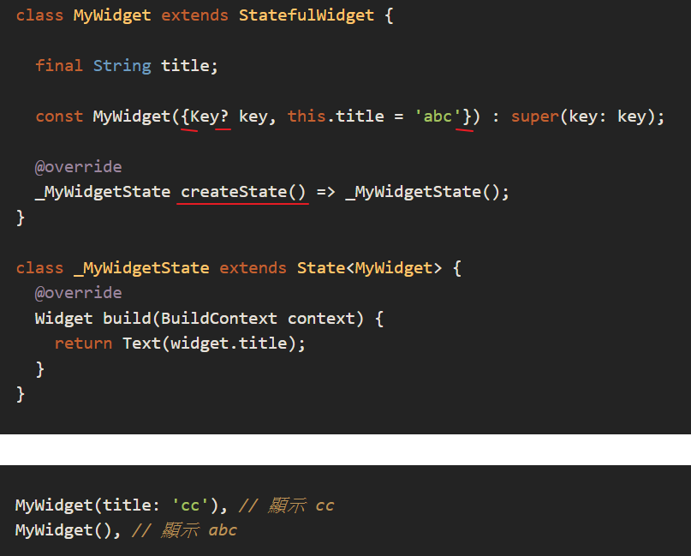

1. Required（被要求一定要傳參數）

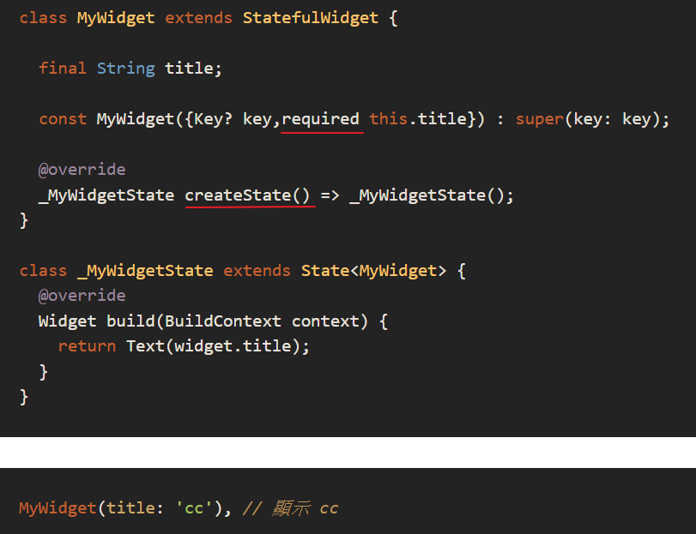

1. 私有化的參數

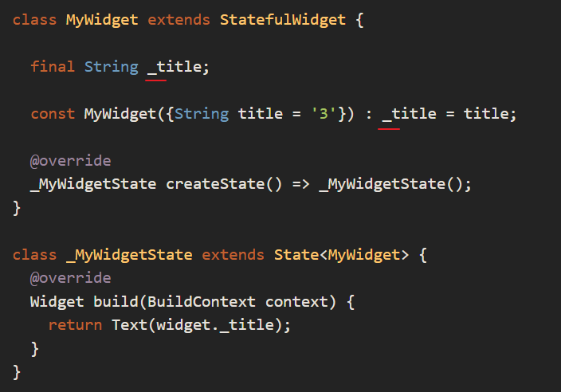

# CallBack

* 我的子元件是一個輸入匡，我的父元件是一個 Scaffold，裡面有一個 showDialog 的 method
* 今天我需要在父元件裡面取得子元件輸入匡的文字傳給 showDialog。

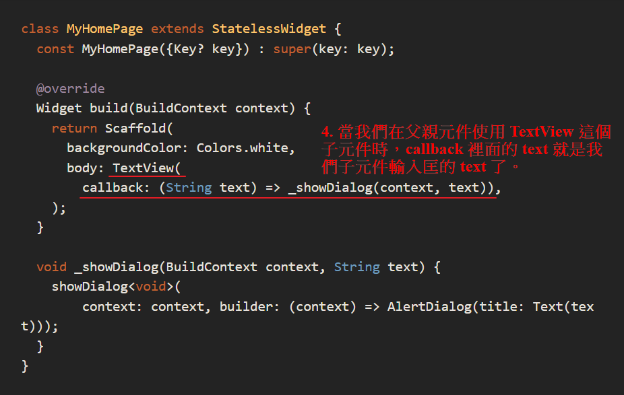

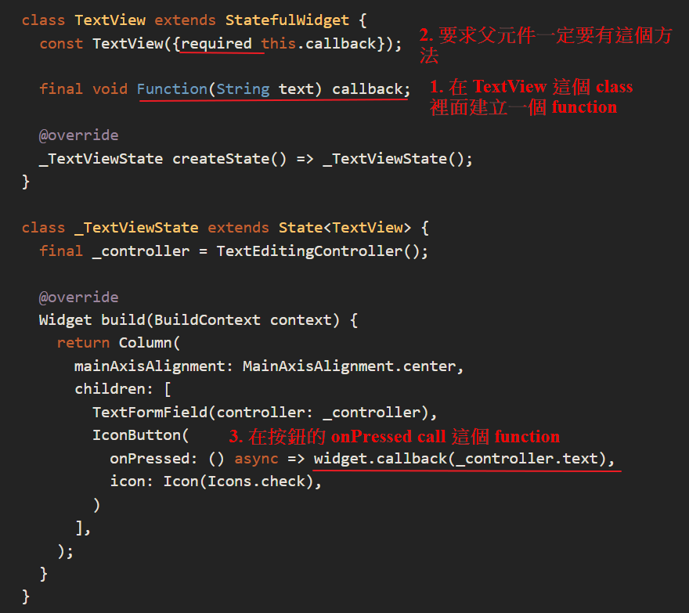

## Json

用到 [json_serializable](https://pub.dev/packages/json_serializable) 的套件和 [Http](https://pub.dev/packages/http) 和 [Equatable](https://pub.dev/packages/equatable)的套件

Equatable 是用來讓物件可以等於物件的

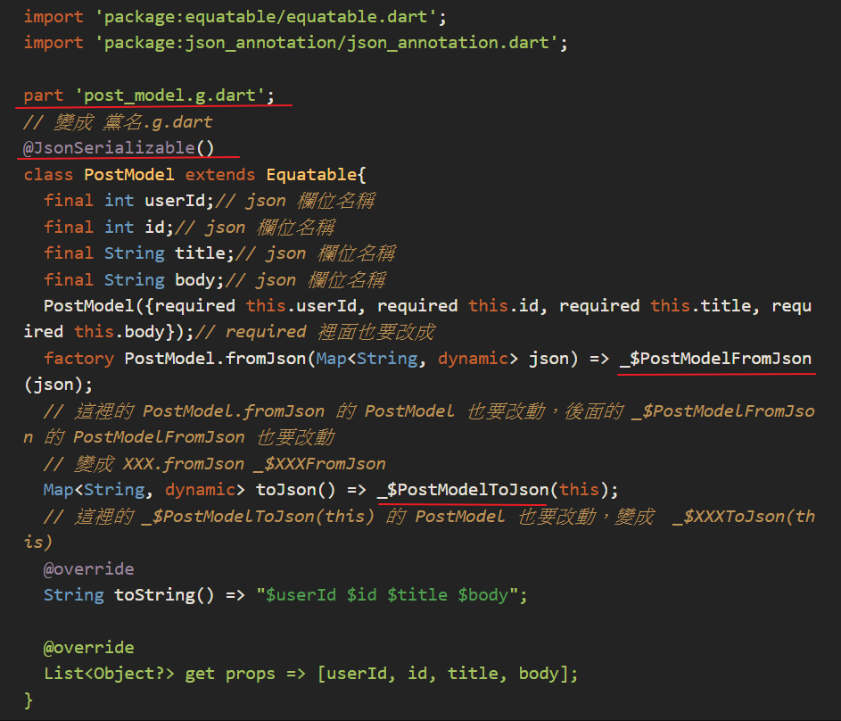

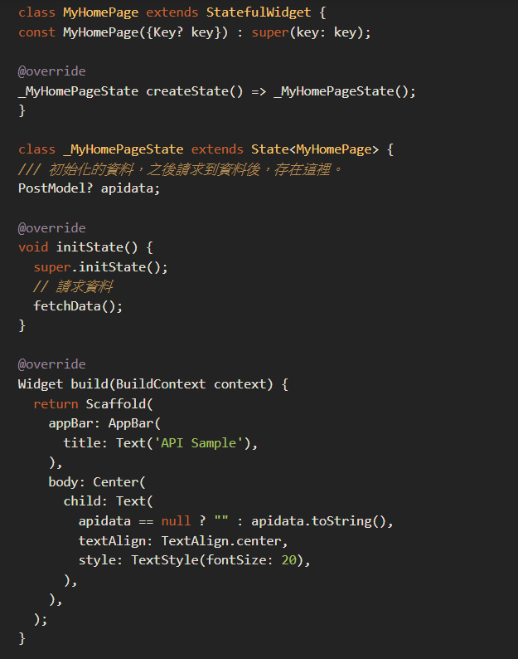

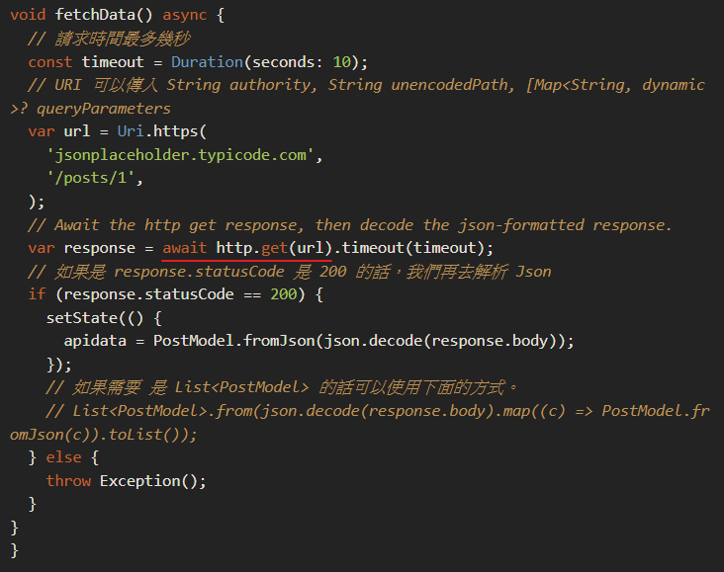

### 自動產生 .g.dart 檔案

這邊超神奇的，我們去終端機吧，下完指令，會產生一個 post_model.g.dart 的檔案

flutter pub run build_runner build .

## HTTP Post 使用

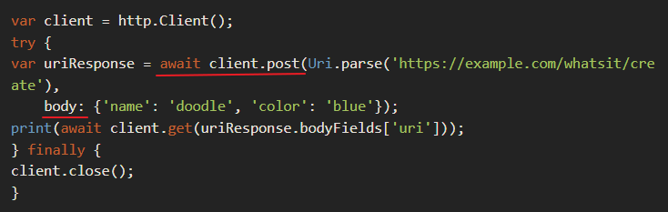

Provider終究只是一個的工具，既不是狀態管理，也不是依賴注入。

Provider可以解決依賴注入和狀態管理的**變數存取問題**，但我們沒辦法只靠Provider就實現依賴注入和狀態管理。

Provider是個widget，依賴InheritedWidget。Provider是一個我們可以自己寫控制器的地方。  
**Provider 是 InheritedWidget 的語法糖**，當你了解到 InheritedWidget 的特性時也會明白 Provider 如何做到依賴注入，所以它不是要改變我們的程式架構，相反的在我們既有的撰寫模式下套用它可以讓程式變得更簡潔。 A dependency injection system built with widgets for widgets. provider is mostly syntax sugar for InheritedWidget, to make common use-cases straightforward.

就如同官網範例 **MultiProvider** 可以協助我們很方便的注入多個 Provider，但是每多註冊一個 Provider 就等於多一層 Widget，Widget 的成本很低，所以效能的差異是可以忽略的，不過如果利用 Dart DevTools 來看 Widget Tree 時應該就會有些抱怨，因為多了很多層，有時候我們可以將多個資源合併在一起來減少堆疊次數。

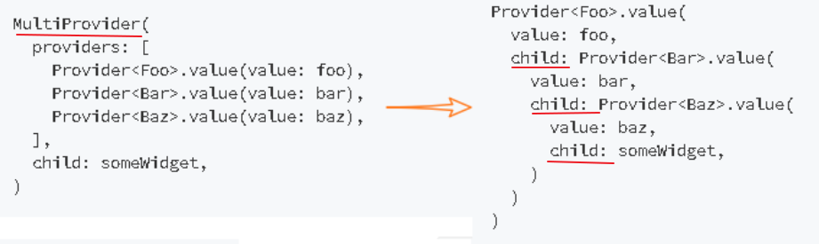

Riverpod不依賴InheritedWidget。 Riverpod裡的Provider已經不再是Widget

如果Function的回傳值是**Future**物件，因為操作都牽涉到網路傳輸，所以會使用**非同步進行 (async)**。

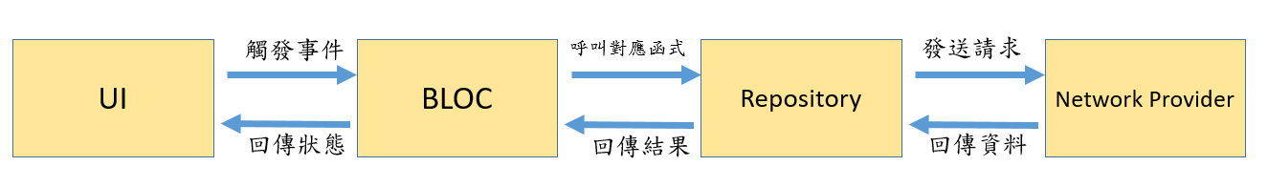

BLoC Design Pattern全名是「Business Logic Component」，用來分離UI層和商業邏輯層，有助於程式碼的維護、重複利用以及測試。  
上面是我畫的示意圖，可能不完全正確但大致能表達意思，BLOC層會接收使用者的行為(例如點擊Button)，根據不同的事件(Event) ，Bloc會去呼叫相應的函式 (可能是去資料庫抓資料或使用api)。之後根據結果回傳相應的狀態(State)給UI層，UI則根據狀態做變化。

# Use **AsyncValue** to replace FutureBuilder or StreamBuilder

**Stream**

Stream是實作Bloc的基礎概念，可以把Stream想成資料流或是一個水管，輸入某些Input (sink)，經過水管內的處理(Business Logic)，它會吐出處理好的Output (Stream)。

使用Stream，UI層就透過可以觸發事件(Sink data)，及監聽Output的Stream達到分離商業邏輯的效果。

使用bloc將觀察點分離，在組件中我們只要處理與 UI 有關的邏輯，將複雜多變的業務邏輯放到 bloc，在開發與維護或是測試工作上都是很不錯的。

bloc、cubit 兩種寫法哪一種適合我：如果你只要處理狀態資料的轉換而不用事件的狀態那簡單應用 cubit 就好。例如：其實我可以用 cubit 處理接收到聊天室的訊息事件即可。

follow 原則： 事件 > 業務邏輯 > 狀態

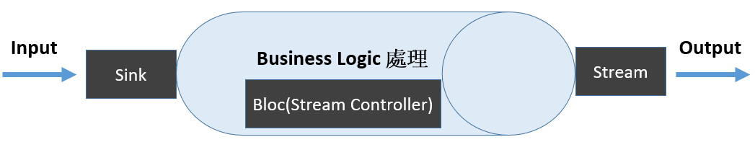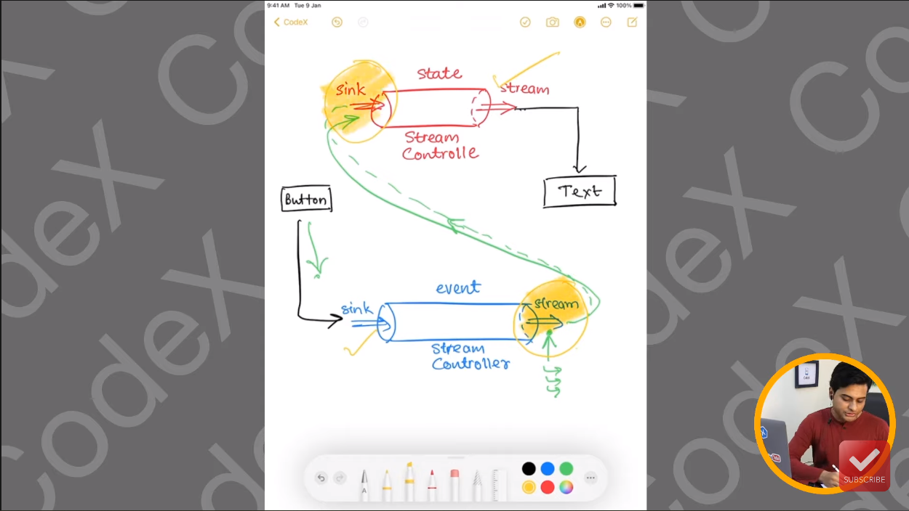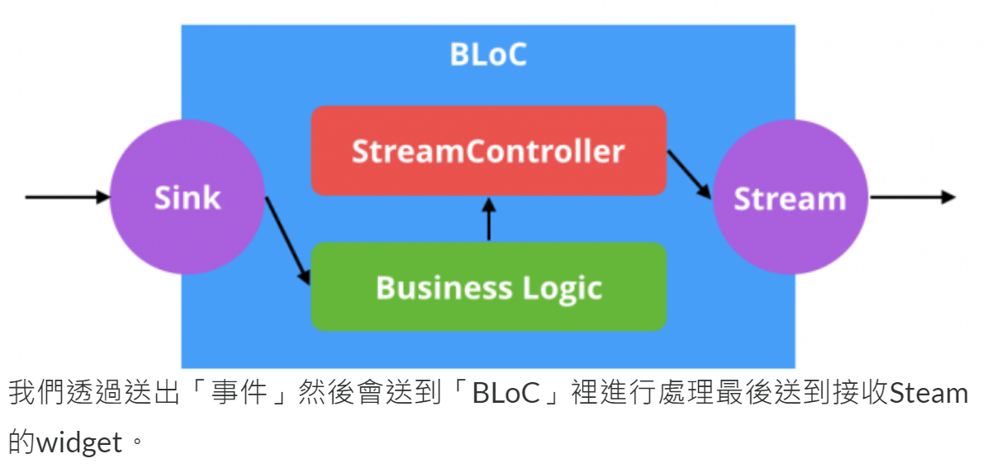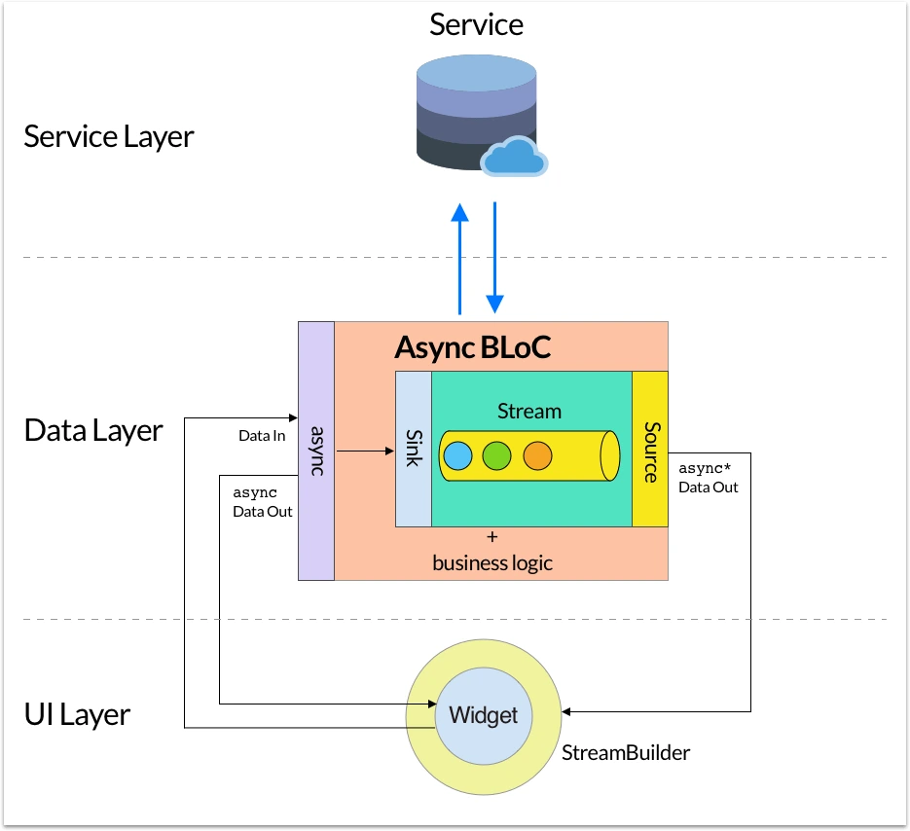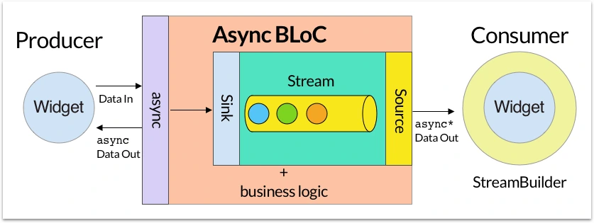

Bloc中可以分成三個，第一個是初始化，第二個是判斷使用者事件，第三個是事件觸發後回傳的狀態，在這裡我們會用到Stream，Stream是用來接收一連串的事件，Stream會監聽目前狀態，若 Stream 有事件，則將告訴監聽器。

使用Bloc取代原本用setState更新 state。

Bloc分成兩個套件：

* Bloc：bloc的核心套件，State、Event、Stream都包含在裡面。
* Flutter_Bloc：配合使用Bloc的Flutter widget，例如BlocBuilder、BlocProvider、BlocListener

Bloc套件很貼心的會將狀態變化記錄下來，可以簡單得用來追蹤使用者的操作跟Debug。

## Blocs

定義Bloc物件需先繼承套件提供的**Bloc class**，並給予定義好的**Event**物件和**State**物件。

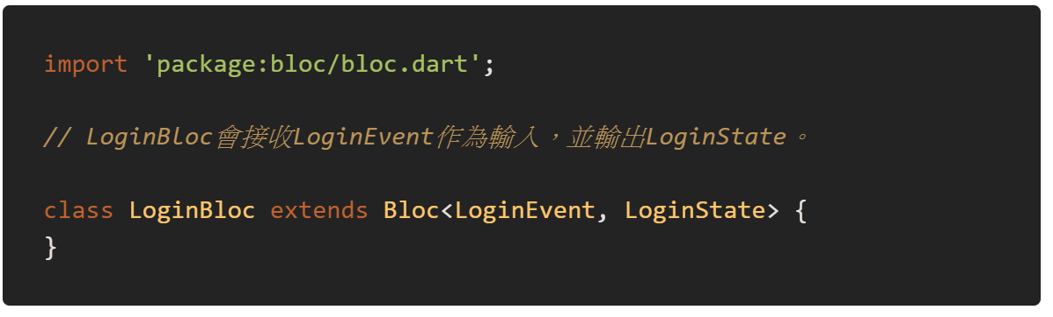

還需要給予Bloc初始的**State**，在還沒接收到任何**Event**前就使用初始的**State**，不然UI會不知道該顯示什麼畫面才好。

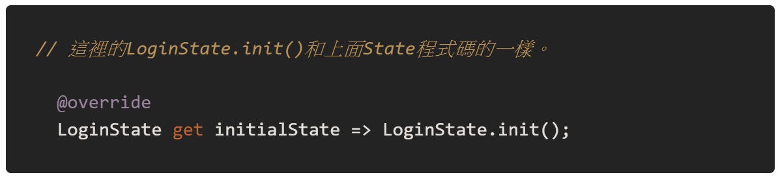

建立Bloc的整個過程，

1. 決定可能的State
2. 會觸發哪些Event
3. 設定初始State以及完成mapEventToState，將觸發的Event轉換到對應的State。

另外一定要實作的是 mapEventToState，將接收到的**Event**用對應的商業邏輯(Business Logic)做處理，最後回傳包裝成Stream的**State**。

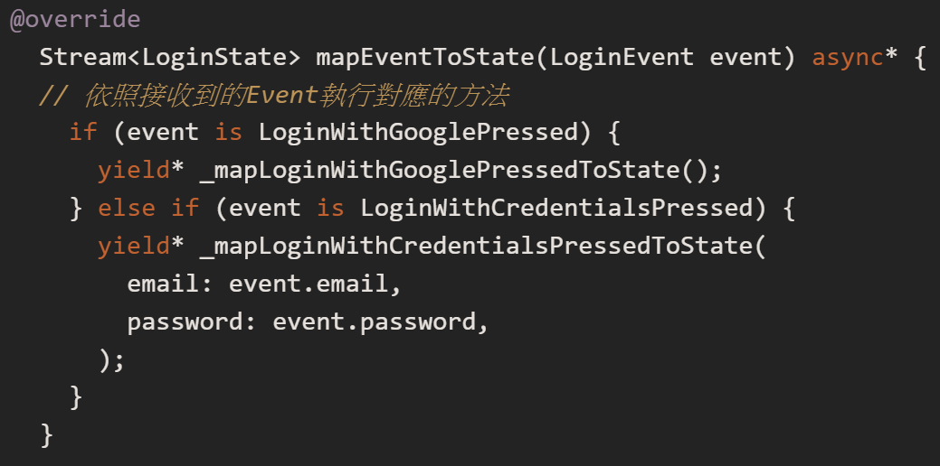

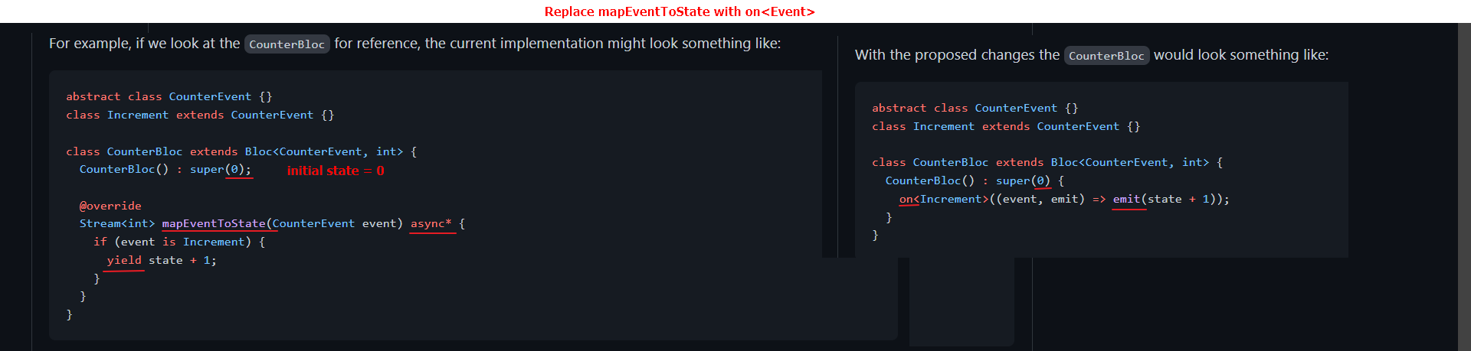

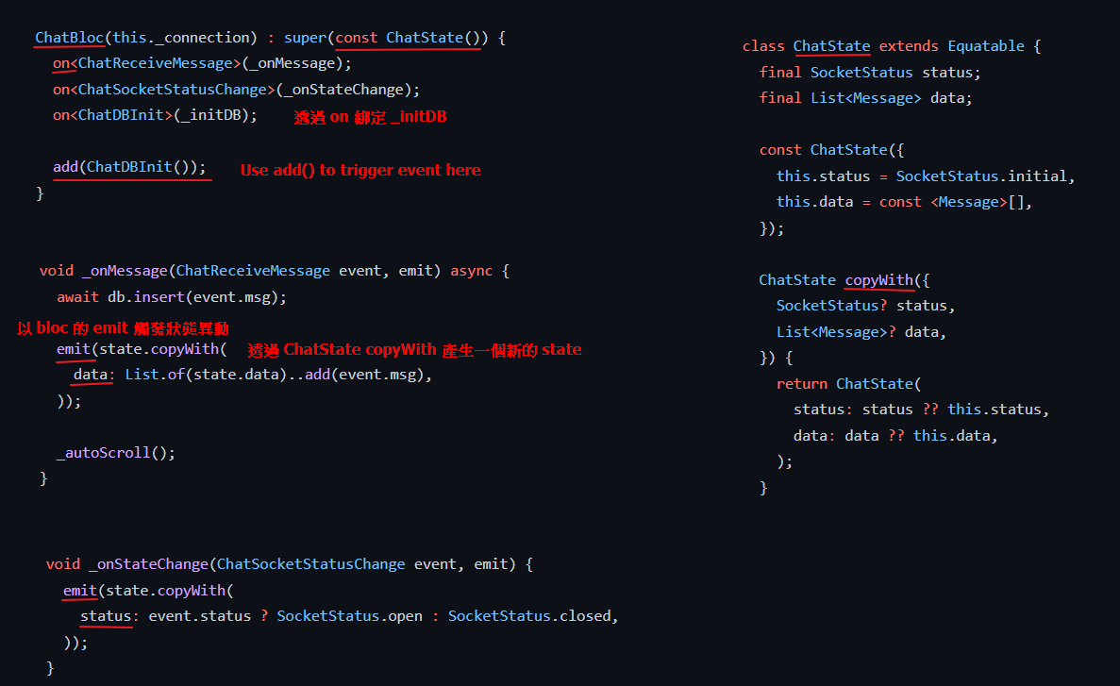

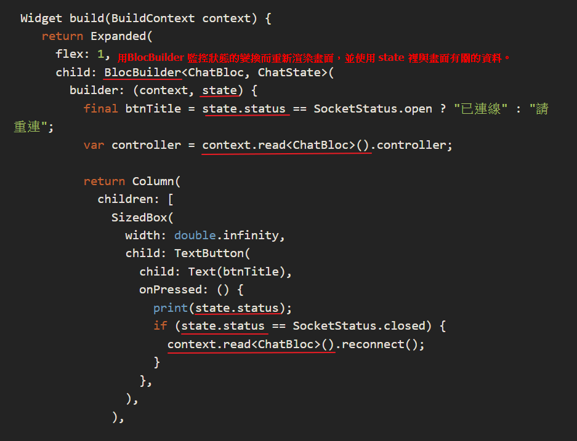

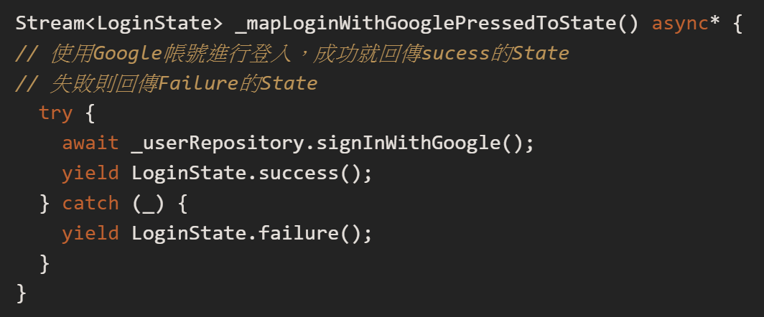

## Dispatch

那麼該如何觸發Event呢?  
Bloc內提供dispatch 方法可以用**Event**作為參數，它會觸發mapEventToState，接著就是執行Event與State的轉換。

### 如何使用 Bloc

BlockBuilder & BlockProvider

## BlocBuilder

BlocBuilder的用途非常好理解，就是當Bloc的State有變化，他會根據你的設計重建App的介面。使用BlocBuilder就不再需要使用setState() 幫我們重繪介面了，一切交由BlocBuilder幫我們處理。Builder會去監聽State的變化，**重建整個畫面**。  
使用BlocBuilder必須從Stateless變成Stateful widget。

BlocBuilder可以處理構建小部件以回應新狀態。

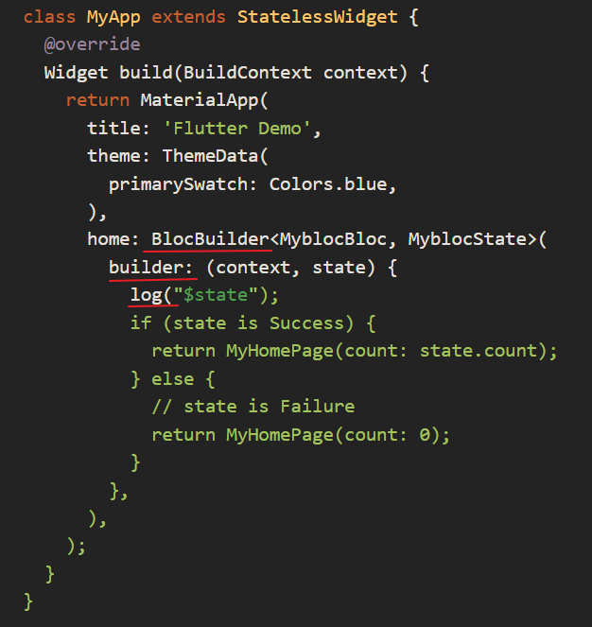

## BlocProvider

BlocProvider的工作就是負責供應Bloc給其他人。它可以將Bloc給他widget tree下的children使用。這個widget非常方便，因為假如你不是使用它而是要自己實作bloc你會需要建立「**inheritedwidget**」才可以讓其他widget使用同個bloc。

另外使用BlocProvider的優點就是它會自動幫你將Bloc關閉 (dispose)，避免記憶體洩漏的問題，你會發覺有BlocProvider處理這些瑣事真好。   
使用BlocProvider會自動幫我們關閉Bloc，但是這裡用到的Controller就要由我們自己關閉囉 dispose()。

BlocProvider負責創建Bloc和一個元件，你將可以使用Bloc所有事件。  
  
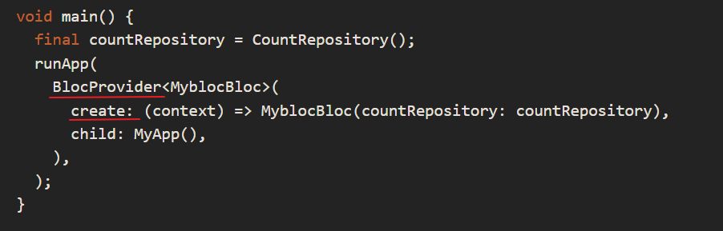

### 使用事件

我們只需要在按鈕onPressed中寫下觸發的事件就可以了。

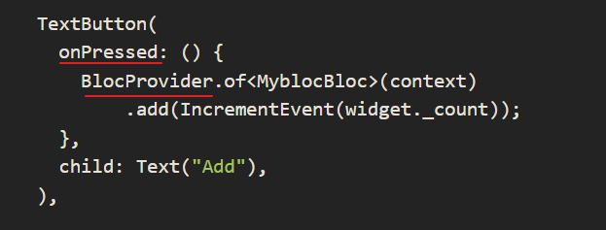

## MultiBlocProvider

(創建多個Bloc) 如果有多個Bloc就可以使用MultiBlocProvider。

## BlocListener

BlocListener和BlocBuilder類似一樣會去監聽State的變化， Listener是用來顯示如SnackBar、Dialog的通知 。(聽取狀態但不能改變元件)

## MultiBlocListener

若有多個Bloc要做監聽一樣有提供MultiBlocListener可以使用。 (聽取多個狀態但不能改變元件)

## Bloc Code Generator Plugin

繼承Equatable是為了能比較兩個物件是否相同(Equatable會幫我們比較兩個實體的屬性值是否全都相同)。

Override toString是為了當onTransition onEvent 觸發時能夠清楚了解現在State的轉換是如何。

有關於async*與yield的用法可以參考[這裡](https://stackoverflow.com/questions/55776041/what-does-yield-keyword-do-in-flutter)。  
重點在於yield會回傳Stream<dynamic>，如此一來UI使用的BlocBuilder或BlocListener就可以接收到新的State並更新介面。  
**yield** adds a value to the output stream of the surrounding ***async\****  function. It's like ***return***, but doesn't terminate the function.

transformEvents是當你想對Stream內的Events在進入到mapEventToState前做處理，就可以override它。

Observable是rxdart套件提供的class，把它當作成Stream即可，它內建許多操作Stream內數值的方法。  
把原本的events轉型成Observable就是為了使用observableStream.where，where是用來filter Stream內的值，只有滿足條件的值才會被篩選。

debounceTime的用途是它會在設定的時間內暫存值，如果時間過了就將它發出；但如果在時間內接收到了同樣的值，時間會重新計算並把前一個丟棄。  
通常在驗證使用者輸入的時候就會使用到debounceTime來緩衝，畢竟沒必要使用者每打一個字元就去檢查一次輸入。  
例如設定0.3秒的意思就是當使用者打字停止了0.3秒後才會去觸發Email或Password改變的Event。

用 Controller 監聽使用者的輸入，檢查是否符合規定。要注意最後要呼叫dispose()將它關閉。

## SharedPreference

sharedPreference能將簡單的資料存放在硬碟內，採用key-value的方式做存取。

## 建立Repository class 用來 call database

## Repository 裡有 apiProvider

## Mockito

•   
Fake：原本要從資料庫取出的資料，改成從存有假資料的Array拿。

• Stub：預設假資料讓測試取用

• Mock：模擬服務運作的流程，並設定回傳特定的資料。

when(...).thenAnswer((_) async => Response(...);  
設定當呼叫到when裡面的程式碼要給什麼樣的回傳值，以這個例子來說會回傳一個Response的物件回去讓程式碼繼續往下執行。

## BuildContext

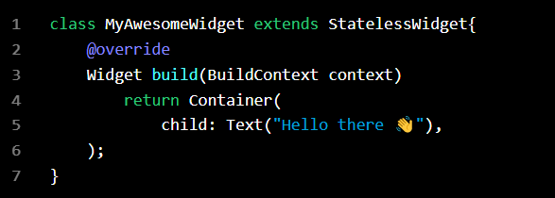

When our widget MyAwesomeWidget is built, the *context* defined in the build method becomes the **parent** of our Widget Tree. In simpler terms, the widgets returned by our build method live “under” the context of our MyAwesomeWidget .

As a result of this behavior, you might have encountered some seemingly strange errors when trying to work with context.

our call to Theme.of(context) will search our Widget Tree for the closest instance of the Theme class.

 every widget we use has its own context and subtree.

Going back to what we learned earlier, the context provided by the builder of MyAwesomeWidget will become the **parent** of the Widget Tree.

As a result, the Scaffold widget lives under the context. Since Flutter uses the context to look up the tree, our Scaffold is missed.

If we look at where MyAwesomeWidget is called, you can see there is no Scaffold acting as the parent of our widget.

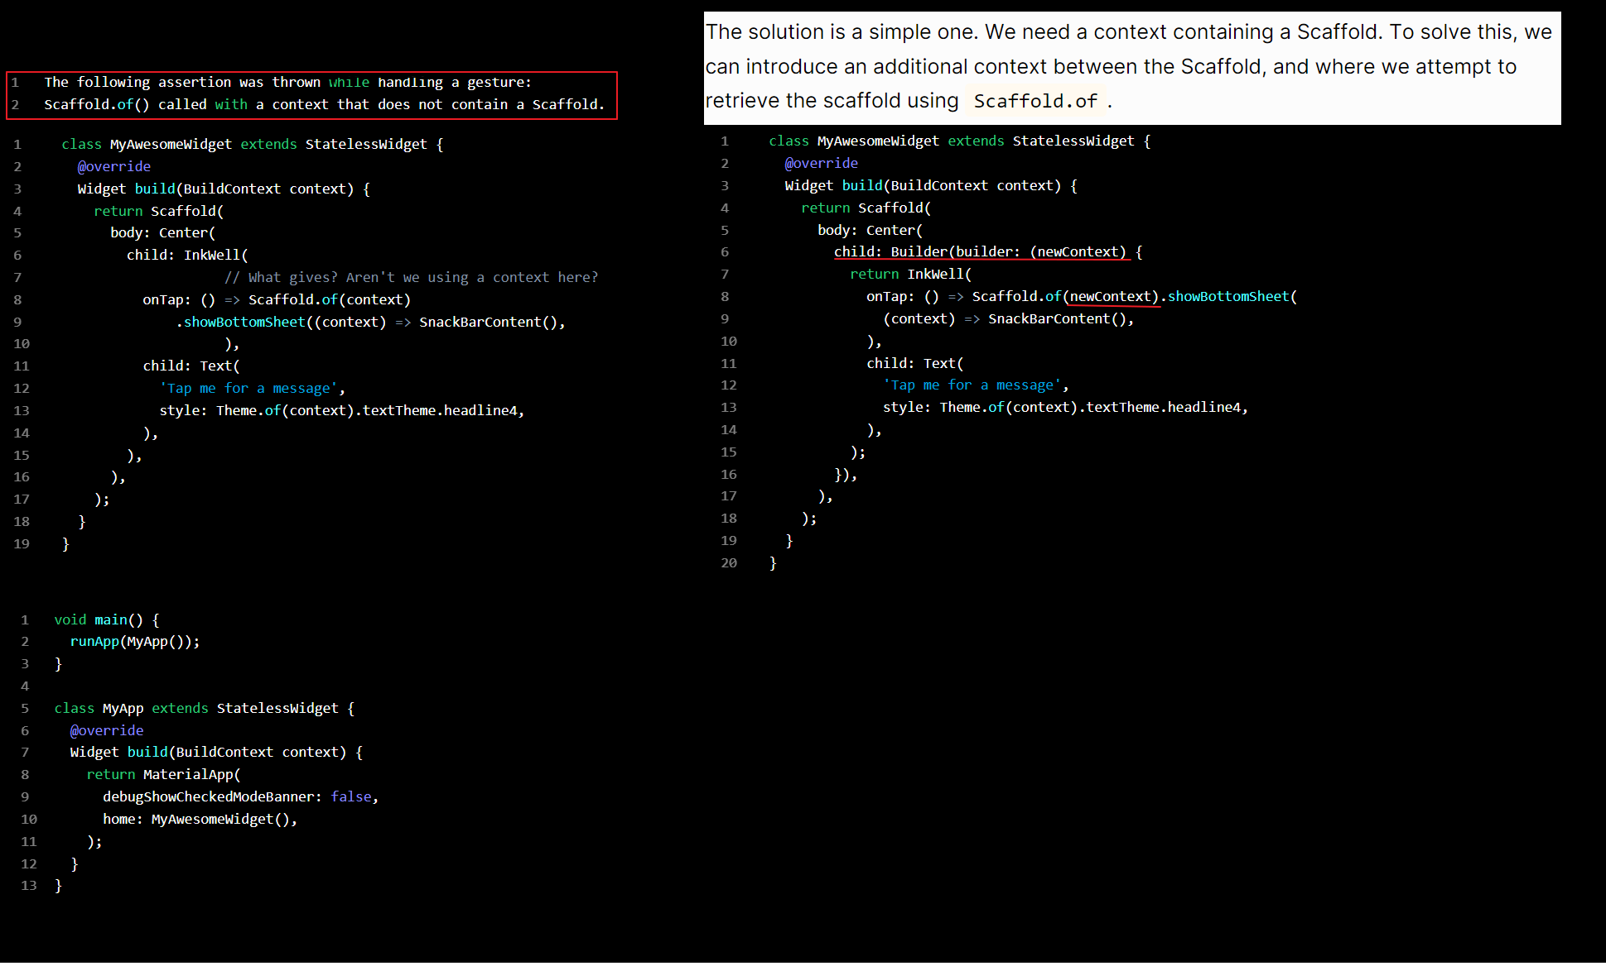

# StatefulWidget lifecycle

on Friday, 24th of July, 2020

When a Flutter builds a [StatefulWidget](https://docs.flutter.io/flutter/widgets/StatefulWidget-class.html), it creates a [State](https://docs.flutter.io/flutter/widgets/State-class.html) object. This object is where all the [**mutable**](https://en.wikipedia.org/wiki/Immutable_object) state for that widget is held.

The concept of state is defined by two things:

1. The data used by the widget might change.
2. The data can't be read synchronously when the widget is built. (All state must be established by the time the build method is called).

The lifecycle has the following simplified steps:

* [createState()](https://flutterbyexample.com/lesson/stateful-widget-lifecycle#1-createstate)
* [mounted == true](https://flutterbyexample.com/lesson/stateful-widget-lifecycle#2-mounted-is-true)
* [initState()](https://flutterbyexample.com/lesson/stateful-widget-lifecycle#3-initstate)
* [didChangeDependencies()](https://flutterbyexample.com/lesson/stateful-widget-lifecycle#4-didChangeDependencies)
* [build()](https://flutterbyexample.com/lesson/stateful-widget-lifecycle#5-build)
* [didUpdateWidget()](https://flutterbyexample.com/lesson/stateful-widget-lifecycle#6-didupdatewidget)
* [setState()](https://flutterbyexample.com/lesson/stateful-widget-lifecycle#7-setstate)
* [deactivate()](https://flutterbyexample.com/lesson/stateful-widget-lifecycle#8-deactivate)
* [dispose()](https://flutterbyexample.com/lesson/stateful-widget-lifecycle#9-dispose)
* [mounted == false](https://flutterbyexample.com/lesson/stateful-widget-lifecycle#10-mounted-is-false)

### Why Are StatefulWidget and State Separate Classes?

In one word: performance.

The tldr version is that State objects are long lived, but StatefulWidgets (and all Widget subclasses) are thrown away and rebuilt whenever configuration changes. It's very inexpensive ie cheap for Flutter to rebuild a mutable widget.

As State isn't blown away on every rebuild, it avoids expensive computations, and gets at the states property, getters, setters etc everytime something is rebuilt frame by frame.

Important is that this is what allows Flutter animations to exist. As State isn't thrown away, it can constantly be rebuilding it's Widget in response to data changes, and when required, if any.

### 1. createState()

When Flutter is instructed to build a [StatefulWidget](https://docs.flutter.io/flutter/widgets/StatefulWidget-class.html), it immediately calls [createState()](https://docs.flutter.io/flutter/widgets/StatefulWidget/createState.html). This method must exist. A StatefulWidget rarely needs to be more complicated than this.

class MyHomePage extends StatefulWidget {

@override

_MyHomePageState createState() => new _MyHomePageState();

}

### 2. mounted is true

When [createState](https://docs.flutter.io/flutter/widgets/StatefulWidget/createState.html) creates the state class, a buildContext is assigned to that state.

A [BuildContext](https://docs.flutter.io/flutter/widgets/BuildContext-class.html) is, overly simplified, the place in the widget tree in which this widget is placed.

All widgets have a bool this.mounted property. It is turns true when the buildContext is assigned. It is an error to call setState when a widget is unmounted.

**tip:** This property is useful when a method on your state calls setState() but it isn't clear when or how often that method will be called. Perhaps its being called in response to a stream updating. You can use if (mounted) {... to make sure the State exists before calling setState().

### 3. initState()

This is the first method called when the widget is created (after the class constructor, of course.)

[initState](https://docs.flutter.io/flutter/widgets/State/initState.html) is called **once and only once**. It must also call super.initState().

This @override method is the best time to:

1. Initialize data that relies on the specific BuildContext for the created instance of the widget.
2. Initialize properties that rely on this widgets 'parent' in the tree.
3. Subscribe to Streams, ChangeNotifiers, or any other object that could change the data on this widget.

@override

initState() {

super.initState();

// Add listeners to this class

cartItemStream.listen((data) {

_updateWidget(data);

});

}

### 4. didChangeDependencies()

The [didChangeDependencies](https://docs.flutter.io/flutter/widgets/State/didChangeDependencies.html) method is called immediately after initState on the first time the widget is built.

It will also be called whenever an object that this widget depends on data from is called. For example, if it relies on an InheritedWidget, which updates.

build is **always** called after didChangeDependencies is called, so this is rarely needed. However, this method is the first change you have to call BuildContext.inheritFromWidgetOfExactType. This essentially would make this State 'listen' to changes on a Widget it's inheriting data from.

The docs also suggest that it could be useful if you need to do network calls (or any other expensive action) when an InheritedWidget updates.

### 5. build()

This method is called often (think fps + render). It is a required, @override and must return a [Widget](https://docs.flutter.io/flutter/widgets/Widget-class.html).

Remember that in Flutter all gui is a widget with a child or children, even ['Padding'](https://docs.flutter.io/flutter/widgets/Padding-class.html), ['Center'](https://docs.flutter.io/flutter/widgets/Center-class.html).

### 6. didUpdateWidget(Widget oldWidget)

[didUpdateWidget()](https://docs.flutter.io/flutter/widgets/State/didUpdateWidget.html) is called if the parent widget changes and has to rebuild this widget (because it needs to give it different data), but it's being rebuilt with the same runtimeType, then this method is called.

This is because Flutter is re-using the state, which is long lived. In this case, required is to initialize some data again, as one would in initState().

If the state's build() method relies on a Stream or other object that can change, unsubscribe from the old object and re-subscribe to the new instance in didUpdateWidget().

**tip**: This method is basically the replacement for 'initState()' if it is expected the Widget associated with the widgets's state nrrds to to be rebuilt!

Flutter always called build() after this, so any subsequent further calls to setState is redundant.

@override

void didUpdateWidget(Widget oldWidget) {

if (oldWidget.importantProperty != widget.importantProperty) {

_init();

}

}

### 7. setState()

The ['setState()'](https://docs.flutter.io/flutter/widgets/State/setState.html) method is called often from the Flutter framework itself and from the developer.

It is used to notify the framework that "data has changed", and the widget at this build context should be rebuilt.

setState() takes a callback which **cannot be async**. It is for this reason it can be called often as required, because repainting is cheap :-)

void updateProfile(String name) {

setState(() => this.name = name);

}

### 8. deactivate()

This is rarely used.

['deactivate()'](https://docs.flutter.io/flutter/widgets/State/deactivate.html) is called when State is removed from the tree, but it might be reinserted before the current frame change is finished. This method exists basically because State objects can be moved from one point in a tree to another.

### 9. dispose()

['dispose()'](https://docs.flutter.io/flutter/widgets/State/dispose.html) is called when the State object is removed, which is permanent.

This method is where to unsubscribe and cancel all animations, streams, etc.

### 10. mounted is false

The state object can never remount, and an error is thrown is setState() is called.

**Dependency injection**

In dart, the most basic way to handle dependency injection is by passing services to a class through the constructor.

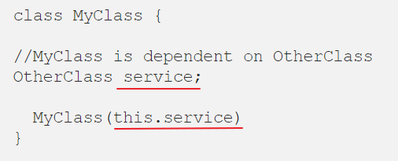  
  
There are many DI methods:  
Inherited Widget — comes with flutter out of the box.

# Inherited Widgets

Inherited Widgets allow you to pass data down widget trees easily. An example of an inherited widget is shown:

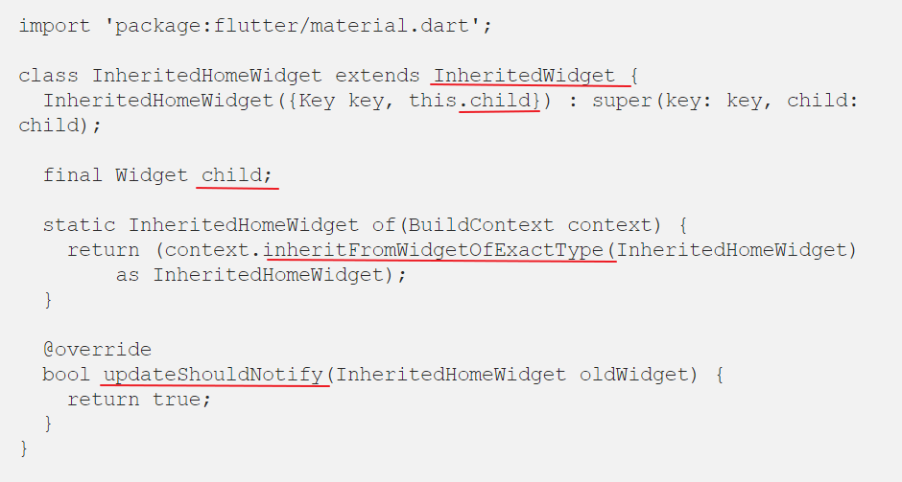

在 **BuildContext** 提供了一個方法 **inheritFromWidgetOfExactType** 可以協助我們由目前的 Widget 所在的 Widget Tree 位置往上尋找**第一個**符合資源型態的資源，習慣上我們也會直接建立一個 static 的 **of 方法**來協助我們搜尋，這表示如果上層 Widget 已經有提供資源，我們可以直接利用 of 方法來抓取，不須重新建立，當然如果將資源綁在最上層(Root Widget)，這個資源就會變成一個全域性的資源，在這個 App 上的任何 Widget 都可以存取到。

This is an auto-generated Inherited Widget from the flutter VS code extension, let’s take a look at what the code contains.

* A widget called child (can be named anything) is passed in, this is where you put your sub widget tree.
* The next block of code looks up the widget tree, finds the closest InheritedWidget and registers the BuildContext with that widget so that it can rebuild the tree when that widget is changed in any way.
* updateShouldNotify() returns a boolean that states whether the subtree widgets should be rebuilt when a change occurs to the InheritedWidget.

**Use In The Widgets**

To make your dependencies available in this widget tree, you can maybe send the dependencies via the Inherited Widget’s constructor, or use a getter, or any way that works for your use case, you will still be able to use it as deep in the tree as you want.

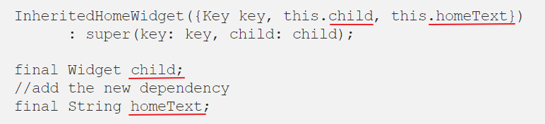

Wrap your entire widget tree with the Inherited Widget you created, if you want your dependencies to be propagated down the whole tree. In this case, I’ll simply pass a text into the constructor, this would likely be an instance of a service.

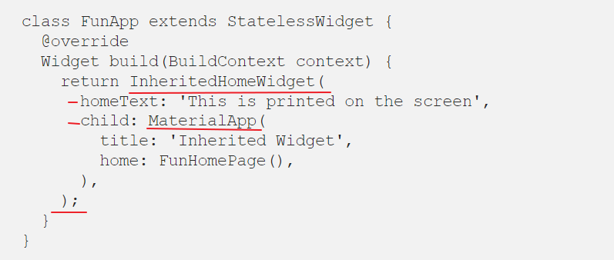

You can then Use that text down the tree by calling .of(context) on the inherited widget, like so:

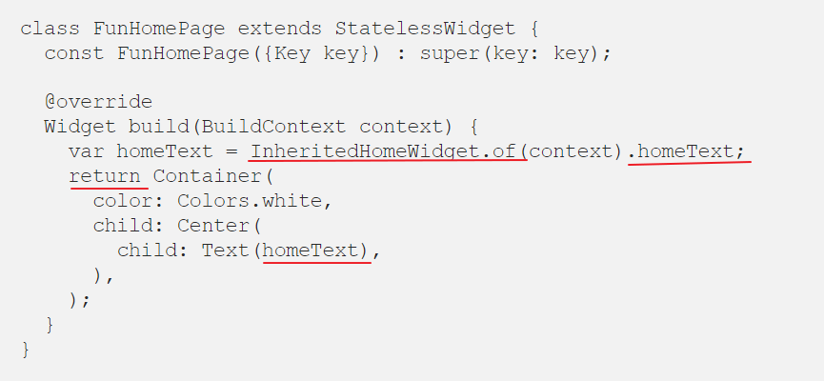

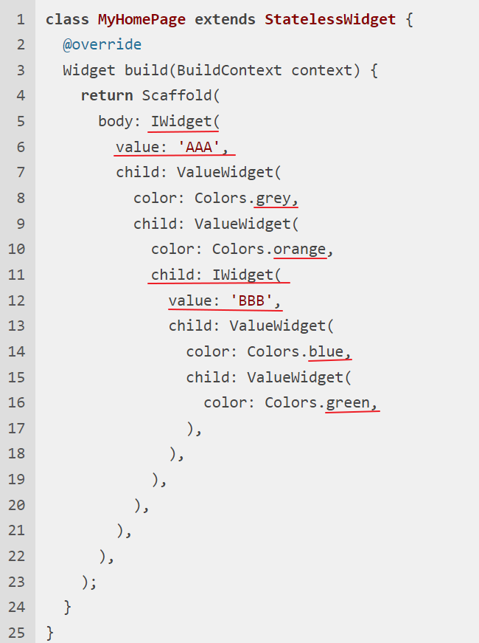 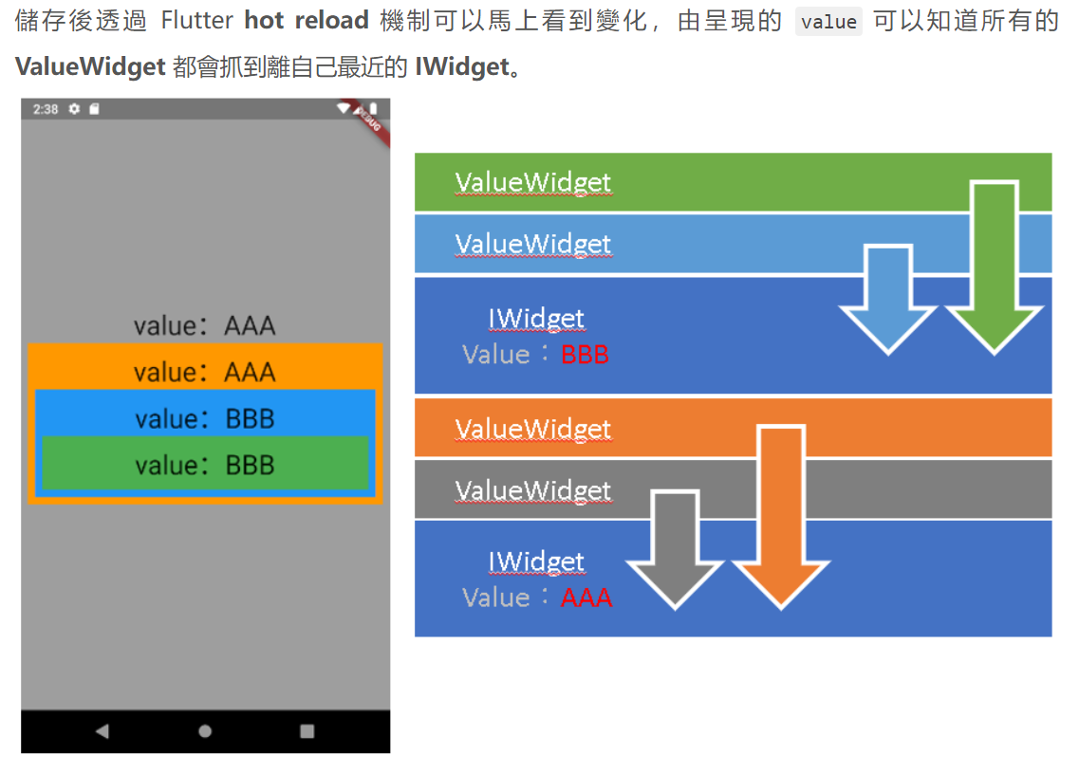

**Riverpod state management**

Just like Flutter tells you to consider everything a widget in the framework, at riverpod I suggest you consider everything a Provider. A Provider can be a function (they are built with functions themselves), a state variable, a global variable (literally), and so on.

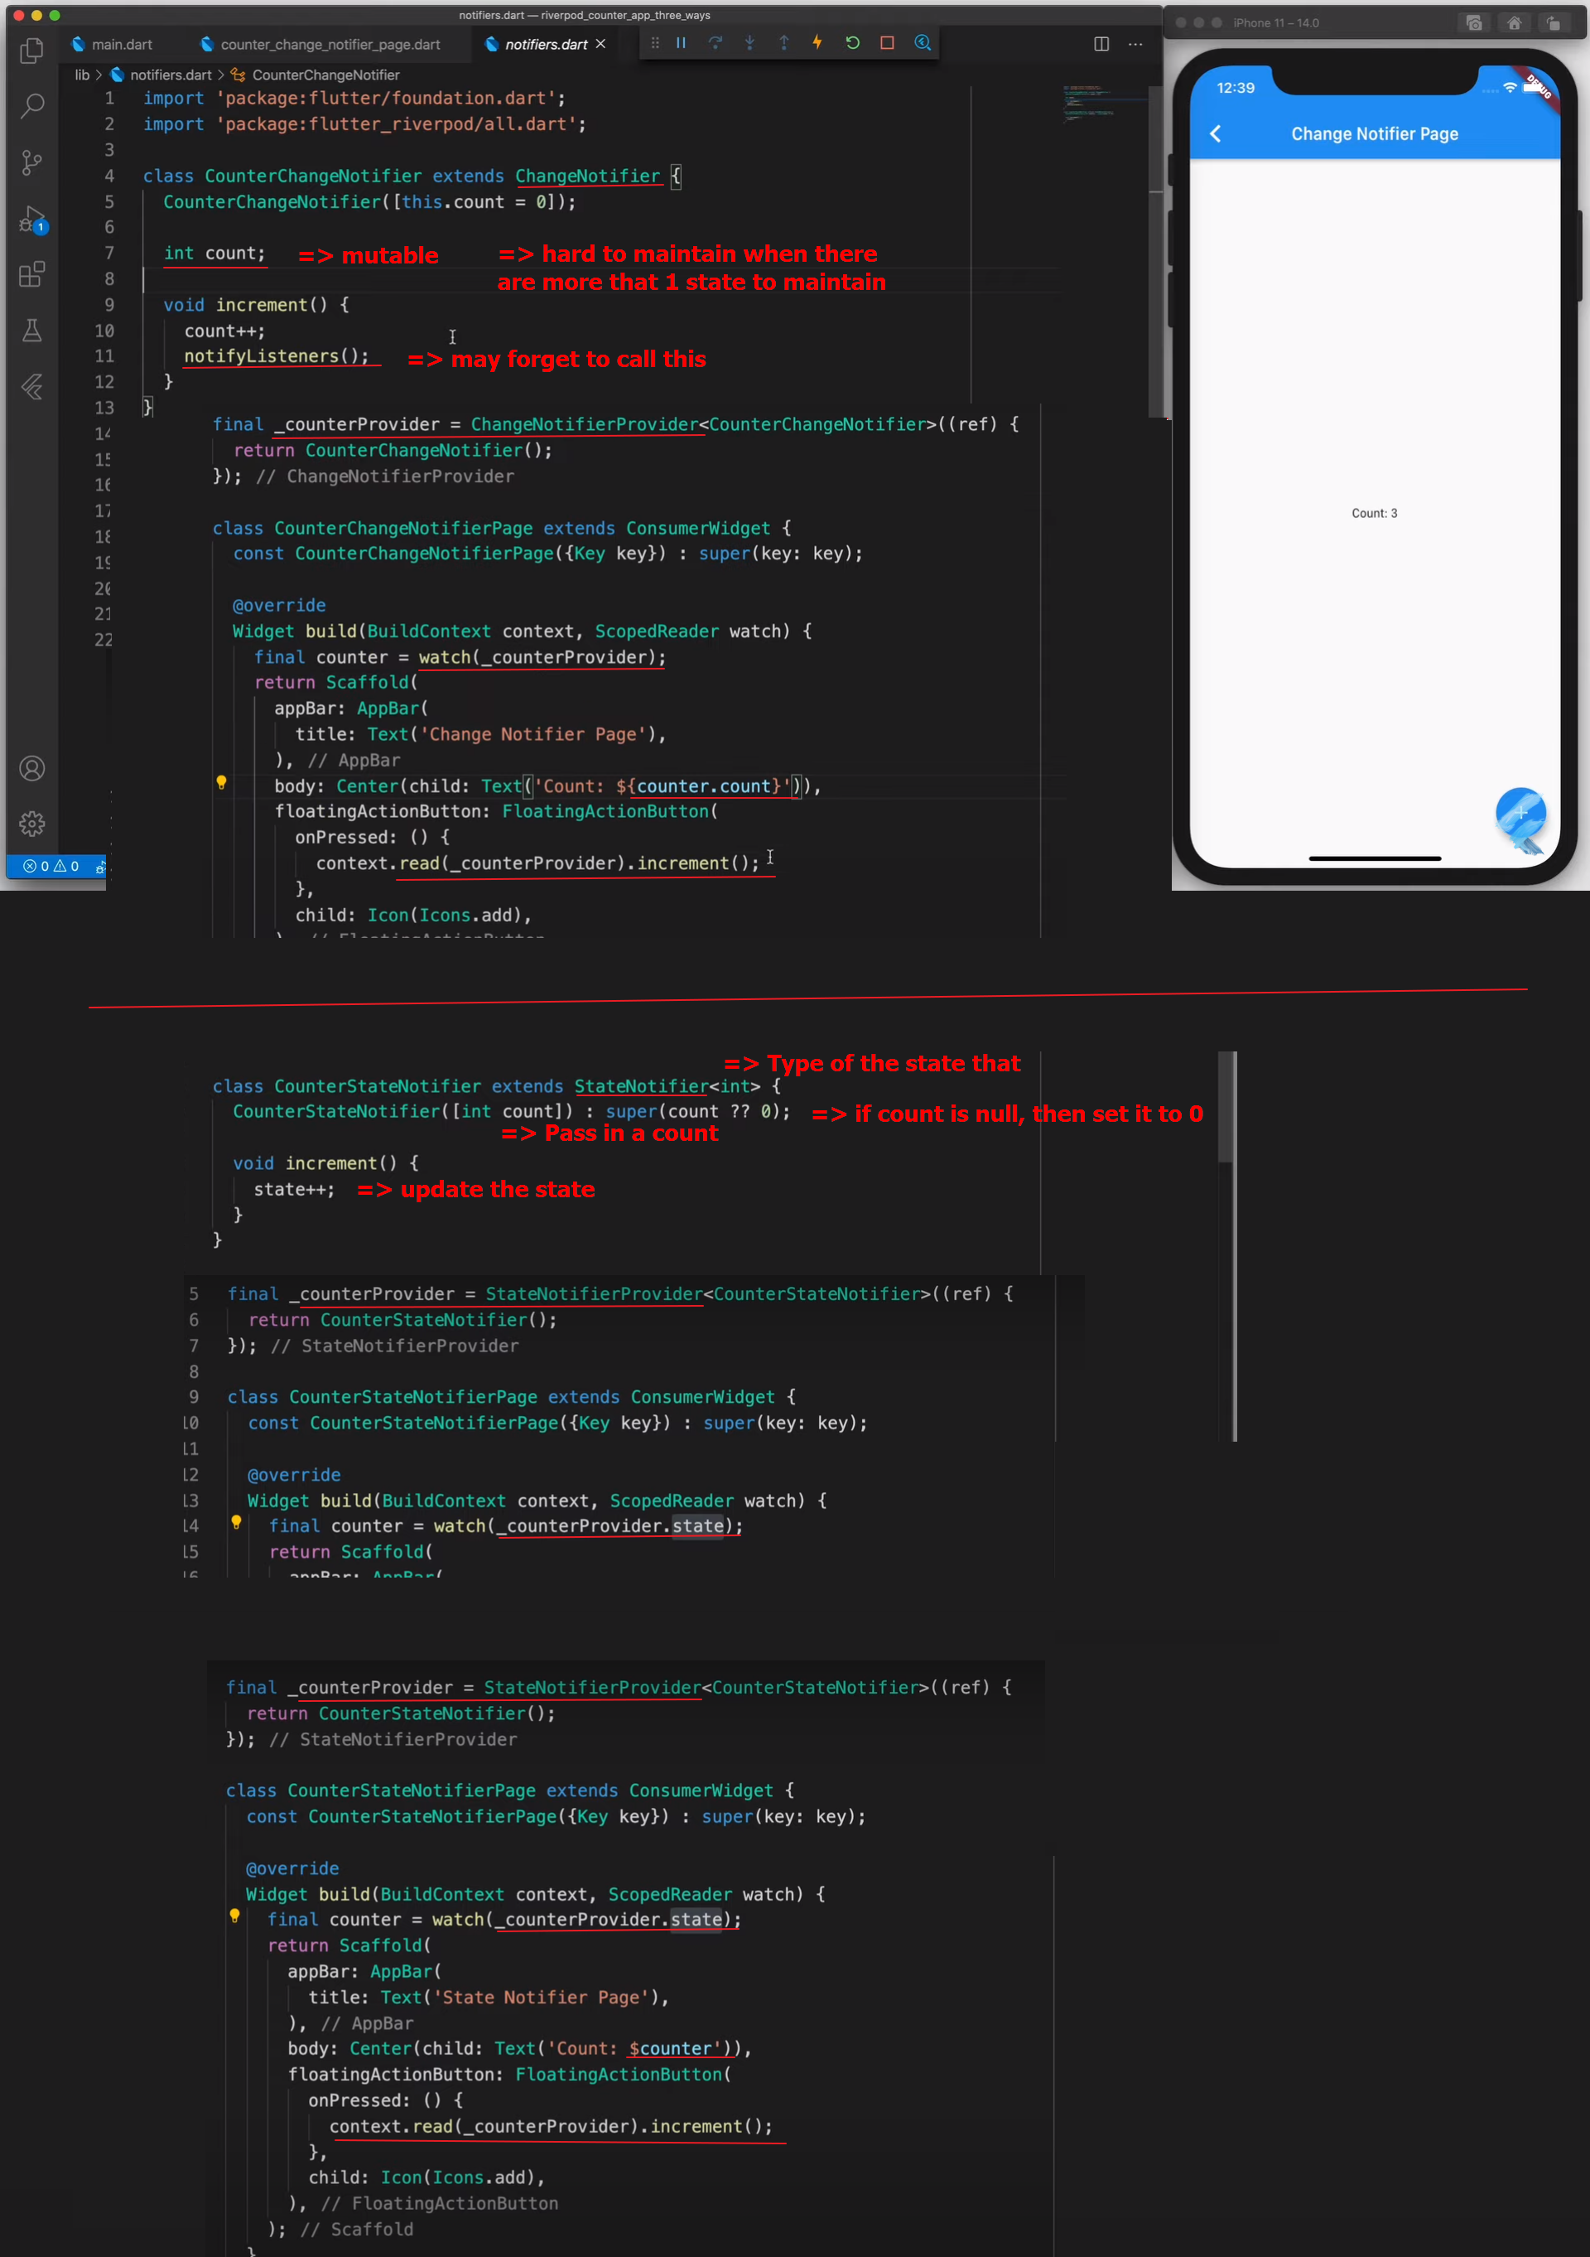

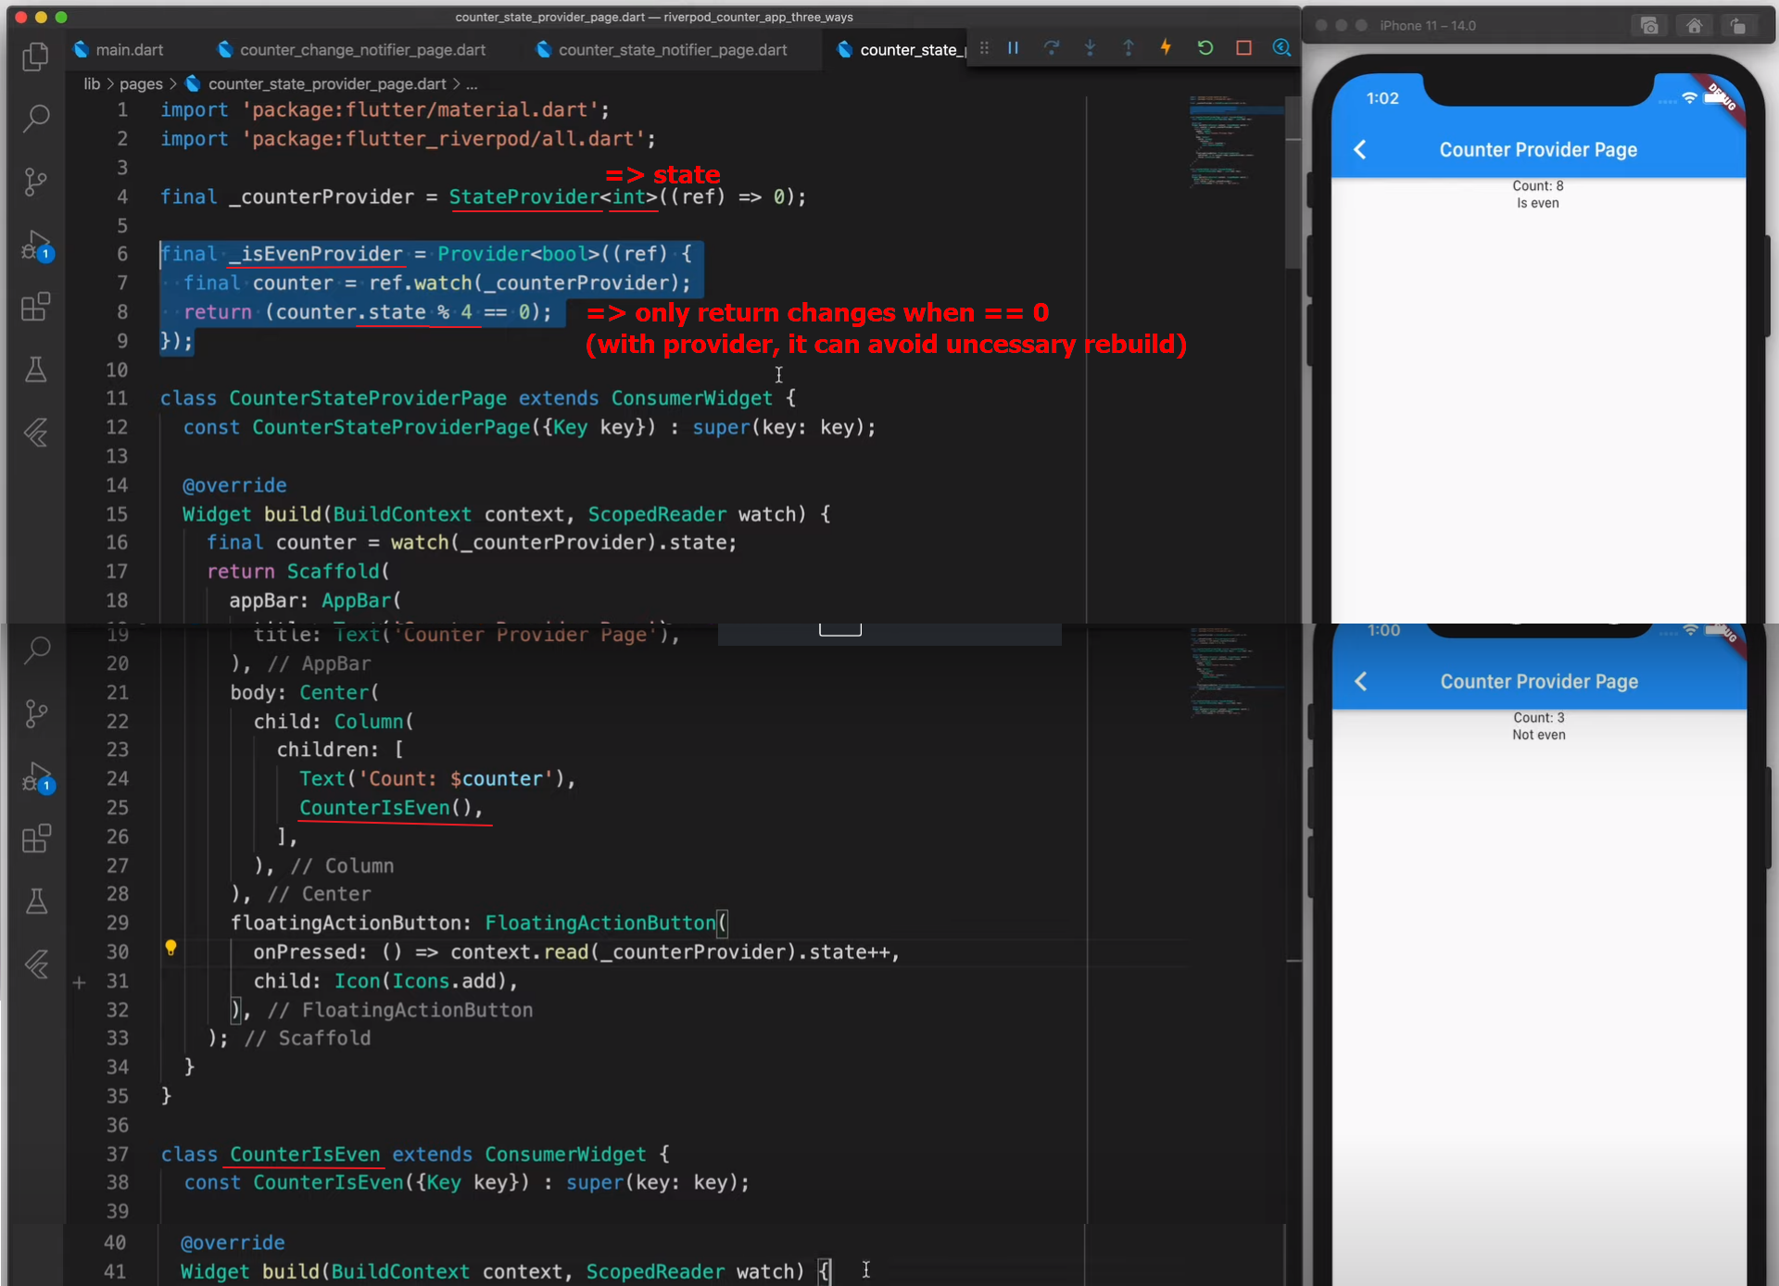

Provider was a tool that allows us to easily use InheritedWidget, which is the class in Flutter that gives access to its properties to its children in the widget tree.

**provider** itself has some problems because of this relationship with **InheritedWidget**.

First, **doesn't allow us to create two Providers of the same type unless they are on a different subtree**.

In simple words, **riverpod** doesn't depend on Flutter so it doesn't depend on **InheritedWidget**, it allows us to combine **Providers** to listen to and react to its changes and it guarantees us reliable code from the compilation stage. It’s a rewrite of **provider**. It solves **provider** problems.

The ChangeNotifier classes used with Provider. They're classes that notify others (widgets included) that are consuming their properties (through Providers). That's the most typical and one of the simplest and most initial ways of handling state with Flutter. *The problem is that it depends on Flutter.*

**StateNotifier** has a lot of things similar to Bloc, including:

* *Initial state* in the **base constructor.**
* *Changes state* through methods.

Actually, the last one is related to **Cubit** not **Bloc**.

*- One difference is that****StateNotifier****assigns the state to the protected variable****state****and****Bloc****uses the****Emitter****class to emit a state, which uses Stream underneath.*

I personally use StateNotifier with [**riverpod**](https://pub.dev/packages/riverpod), the provider rewrite, and I quite like the combination as it includes it by default. Handling states much like the way flutter_bloc does seem very convenient and makes code more predictable, which is very good. All this added to the fact that the state assignment syntax is simpler and facilitates its emission.  
Handling states as classes were much more convenient and helped to modularize your widgets based on the current state.

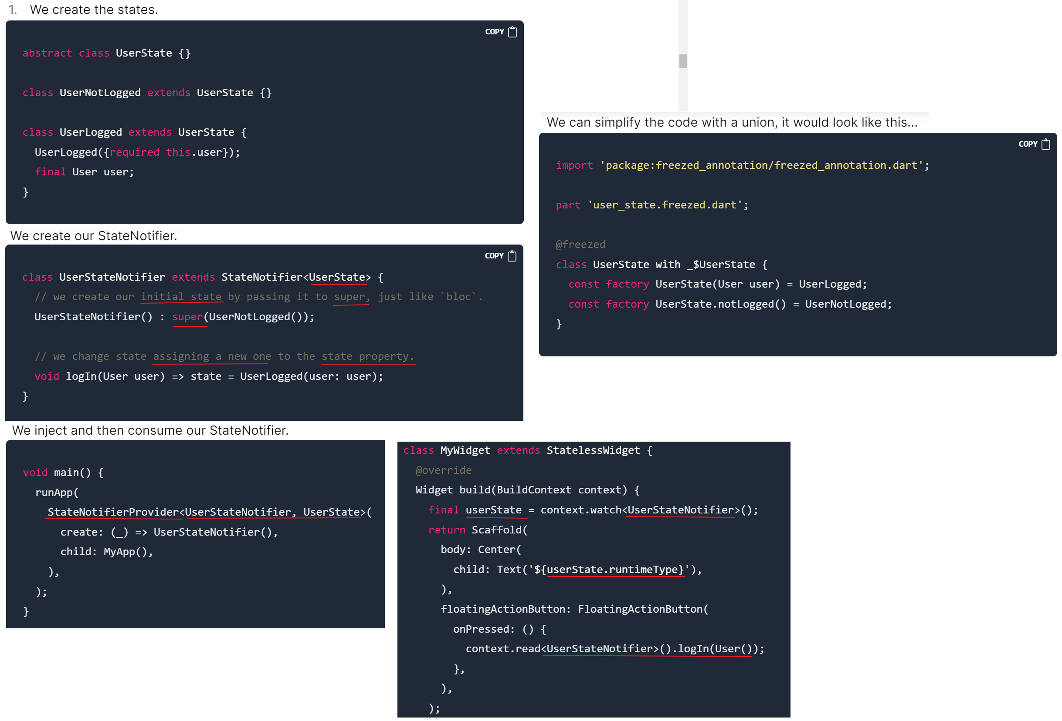

# **Creating better states with classes**

You can see that we created an **abstract state** that can be used by any class through **inheritance**. This is a practice that I first saw in **bloc**, where **defined events** alter the **current state** of a **Bloc**. It's very good because we define in the **Bloc** that we're going to **send a state** that inherits from an **abstract state**, as we saw in the example.

With **StateNotifier**, this is excellent when passing a specific type of data (our abstract state) and assigning it as we need.

The problem with this is that it gets a bit slow and we write boilerplate code when we have several possible states. For this reason, we are including another package called [**package:freezed**](https://pub.dev/packages/freezed), which works amazingly with **StateNotifier**.

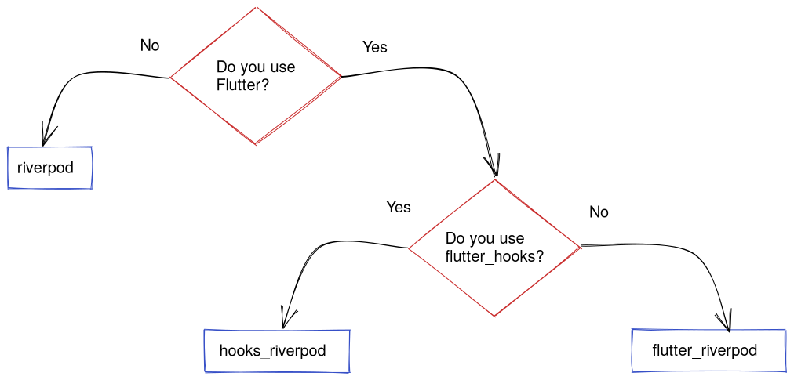

## New way to create Providers

Once our **ProviderScope** is declared, we can use any **Provider** below it. Now let's see how we make a **Provider**.

In the case of **provider**, we create a class that inherits from **ChangeNotifier**, **StateNotifier**, a repository or service class of its own. **riverpod** comes with **StateNotifier** by default, so it's easier to implement this alternative, same way there are more types of Providers than we will talk about in a moment.

We can use this **NamesNotifier** both in **provider** and **riverpod** because the logic components are not affected by the package, which already takes care of incorporating this component into the widget tree for use.

In **provider**, we need to include the packages [**state_notifier**](https://pub.dev/packages/state_notifier) and [**flutter_state_notifier**](https://pub.dev/packages/flutter_state_notifier).   
In **riverpod**, these are not needed since [**flutter_riverpod**](https://pub.dev/packages/flutter_riverpod) contains the **ConsumerWidget** (equivalent to the **Consumer** widget in **provider** but used more similar to **StatelessWidget**).

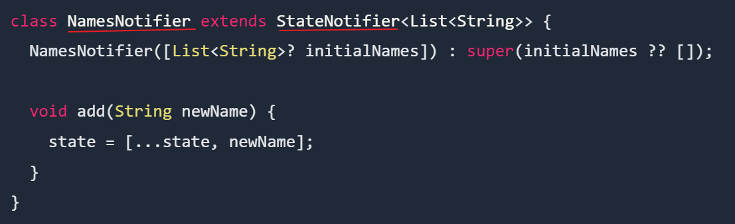   
  
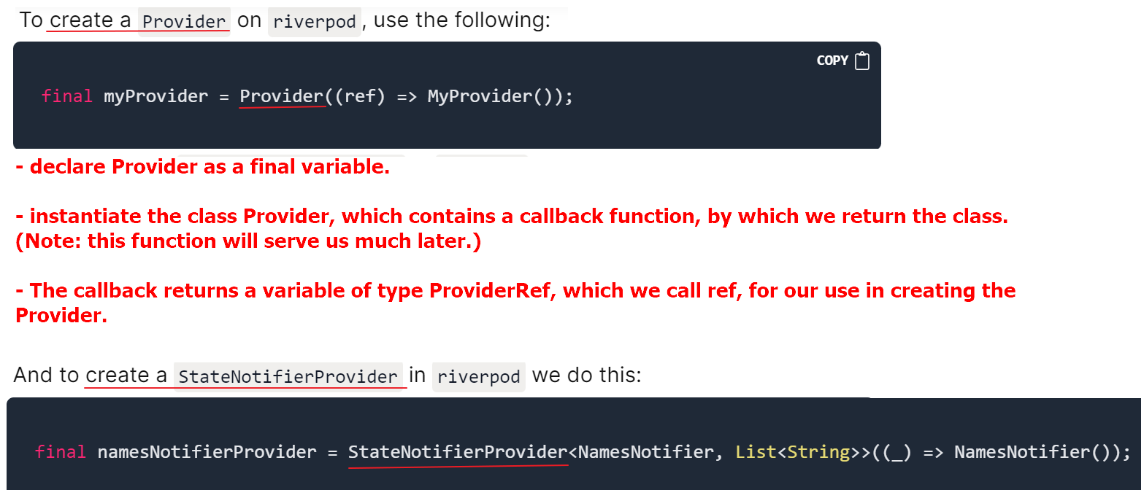

Once declared, no matter what file it's in, the Provider is in the ProviderScope and is available wherever it is needed via ProviderRef.

## Use of Providers with Widgets

We can do it in two ways...

* Use **ConsumerWidget**. (preferred)
* Use **Consumer** widget.

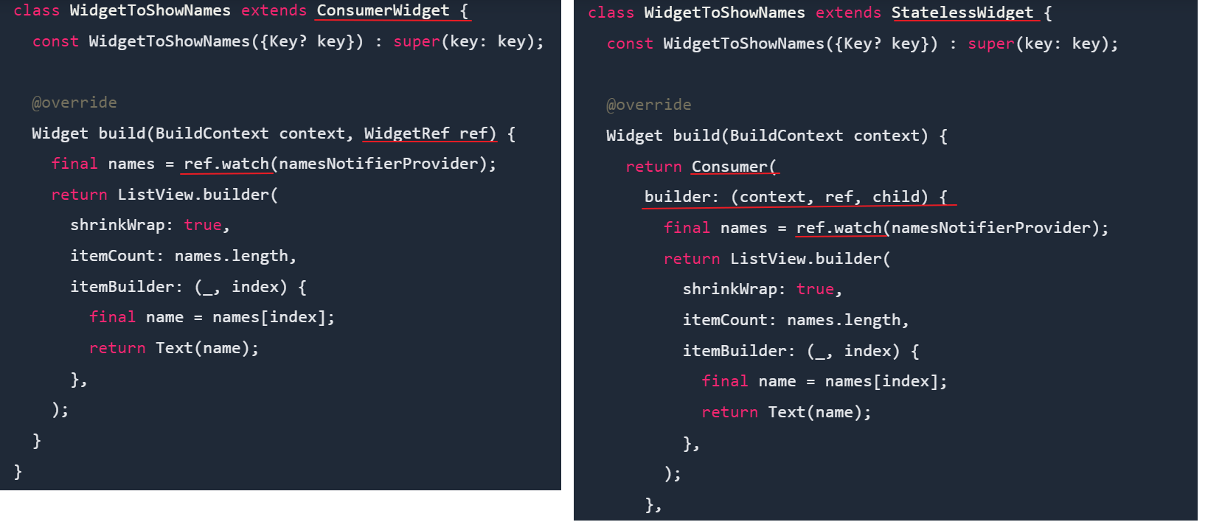

## How to structure Providers

* Separate project folders by functionalities (**features**).
* In a specific functionality I try to have a **/provider** folder where I have all my **Providers**.
* I don't have more than one logic component (**StateNotifier**) for functionality.
* In the **/provider**  folder, I separate my **state**, **logic component**, and **Provider** in separate files. You can also have a generated **freezed** file if you use that tool for state union classes.

With the rules, we have a folder structure like this...

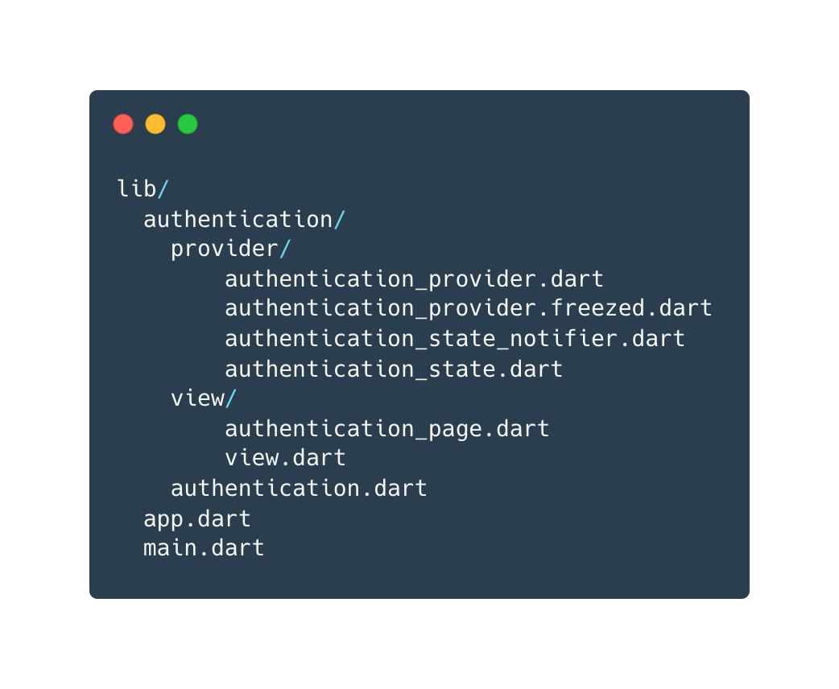

## Provider types

I'm going to present to you the most common and used types of **Providers** so far.

* **StateProvider**: Exposes a value that can be modified from outside. We access the state through the **state** variable and we can change it. Very similar to **ValueNotifier**.
* **StateNotifierProvider**: Create a **StateNotifier** and expose its state. The most used for logic components, it allows easy access to **state**, which is usually a private property that's modified by public methods.
* **FutureProvider**: Constructs an asynchronous value or **AsyncValue** and has the operation of an ordinary **Future**. It's useful to load data from a service whose method to obtain this data is asynchronous.
* **StreamProvider**: Create and expose the last value in a **Stream**. Ideal for communication in real-time with Firebase or some other API whose events can be interpreted in **Stream**.
* **ScopedProvider**: Defines a **Provider<T>** (of a generic type) that behaves differently somewhere in the project. It's used in conjunction with the **overrides** property of **ProviderScope** and defines with the latter the scope where this **ScopedProvider** is going to be modified.
* **Provider.Family**: This type of **Provider** is a modifier, that is, all of the above can use it. In itself, it defines an additional parameter that's involved in the creation of our **Provider**, such as a **String**.

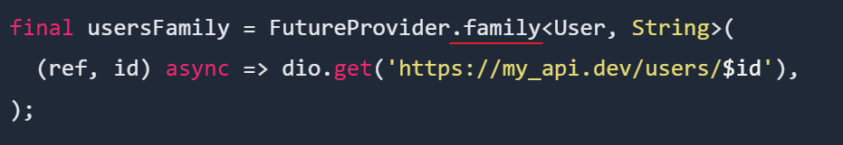

* **AutoDisposeProvider**: Another modifier that allows us to automatically **dispose** of our **Providers**, allowing us to delete the state when the widgets where they are used are destroyed.

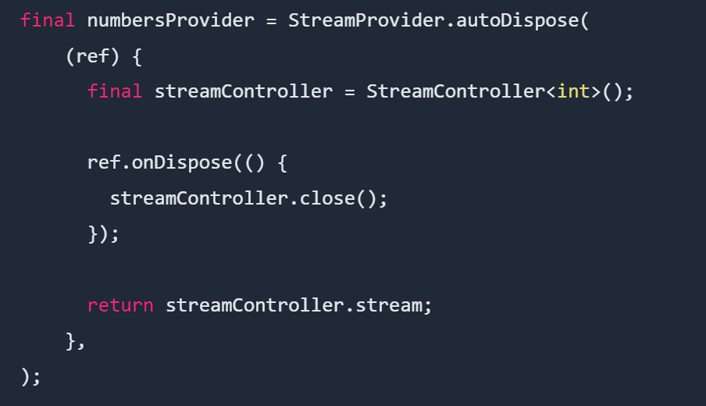

**Riverpod**

Riverpod architecture has a clearer distinction between controllers (which manage the widget state)

and services (which manage the application state).

Riverpod makes it possible to watch different kinds of data (Streams, Futures, StateNotifiers, ChangeNotifiers etc.)

1. final fileServiceProvider = Provider((_) => FileService());
2. final settingsManagerProvider = ChangeNotifierProvider((**ref**) {
3. **return** SettingsManager(() => **ref**.read(fileServiceProvider));
4. });
5. final appManagerProvider = ChangeNotifierProvider((**ref**) {
6. **return** AppManager(() => **ref**.read(fileServiceProvider));
7. });

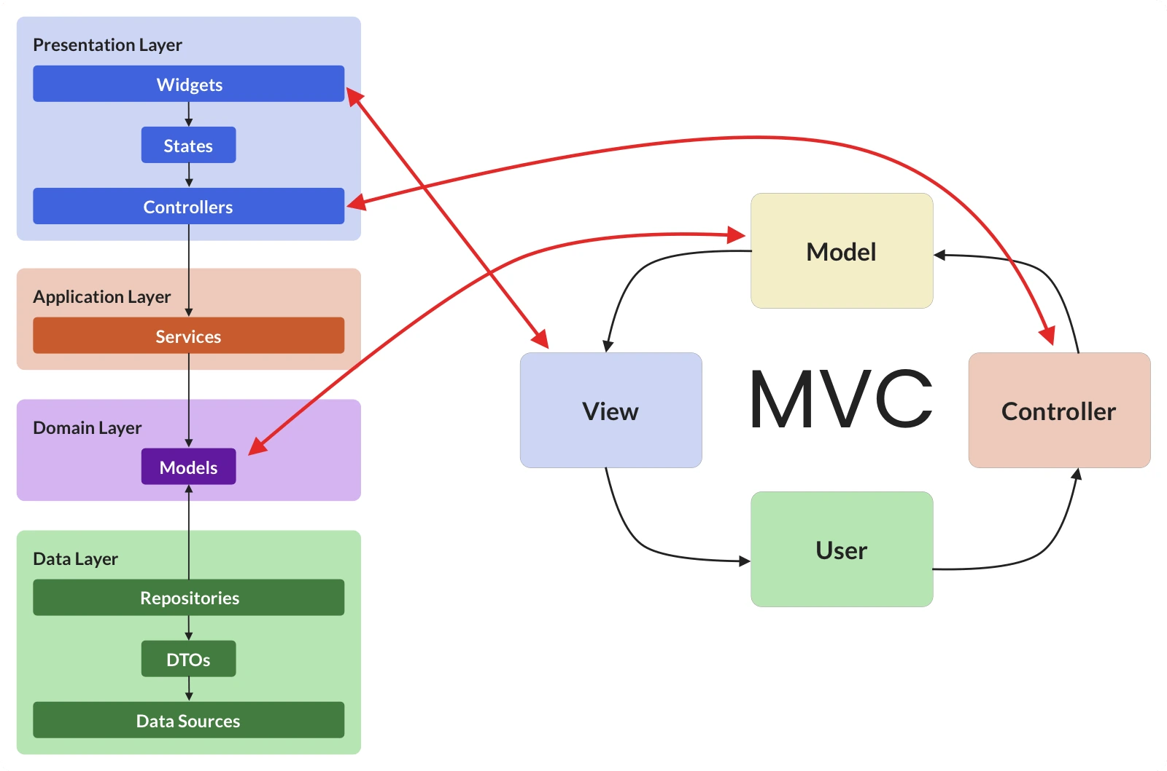

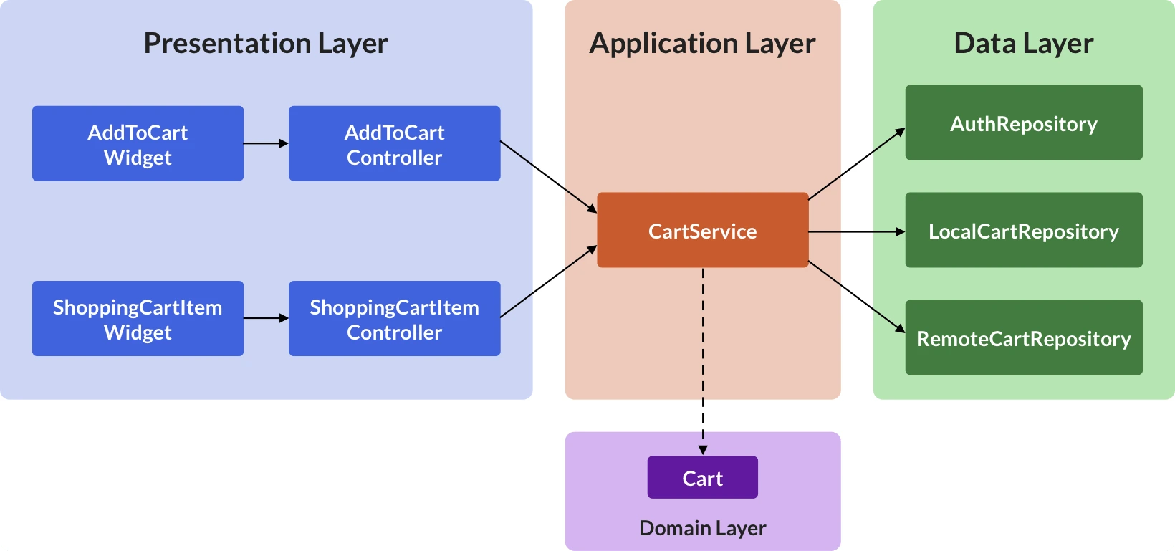

Presentation layer:

controller =>

hold business logic

manage the widget state

interact from view with repositories in the data layer

provide a way for the widget to observe state changes and rebuild itself as a result  
talk to the repository on behalf of the widget

emit state changes as needed

## [A controller class based on StateNotifier](https://codewithandrea.com/articles/flutter-presentation-layer/#a-controller-class-based-on-statenotifier)

The first step is to create a [StateNotifier](https://pub.dev/documentation/state_notifier/latest/state_notifier/StateNotifier-class.html) subclass:

import 'package:flutter_riverpod/flutter_riverpod.dart';

// Create a StateNotifier subclass using AsyncValue<void> as the state

*class* SignInScreenController *extends* StateNotifier<AsyncValue<void>> {

SignInScreenController({*required* this.authRepository})

// set the initial value

: super( const AsyncData<void>(null) );

*final* AuthRepository authRepository;

Future<void> signInAnonymously() *async* {

state = const AsyncLoading<void>();

state = *await* AsyncValue.guard<void>(authRepository.signInAnonymously);

}

}

we need to specify the **type** of the state class we want to use, in this case, we choose AsyncValue<void>

AsyncValue<void>, as this allows us to represent three states:

* **default** (not loading) as [AsyncData](https://pub.dev/documentation/riverpod/latest/riverpod/AsyncData-class.html) (same as AsyncValue.data)
* **loading** as [AsyncLoading](https://pub.dev/documentation/riverpod/latest/riverpod/AsyncLoading-class.html) (same as AsyncValue.loading)
* **error** as [AsyncError](https://pub.dev/documentation/riverpod/latest/riverpod/AsyncError-class.html) (same as AsyncValue.error)
* Then, we call AsyncValue.guard (which is a handy alternative to try/catch) and await for the result (which will be either AsyncData or AsyncError)

### Creating a StateNotifierProvider  that we will use in our widget class:

*final* signInScreenControllerProvider =

// StateNotifierProvider takes the controller class and state class as type arguments

StateNotifierProvider.autoDispose<SignInScreenController, AsyncValue<void>>(

(ref) {

return SignInScreenController(

*authRepository:* ref.watch(authRepositoryProvider),

);

});

## [Using our controller in the widget class](https://codewithandrea.com/articles/flutter-presentation-layer/#using-our-controller-in-the-widget-class)

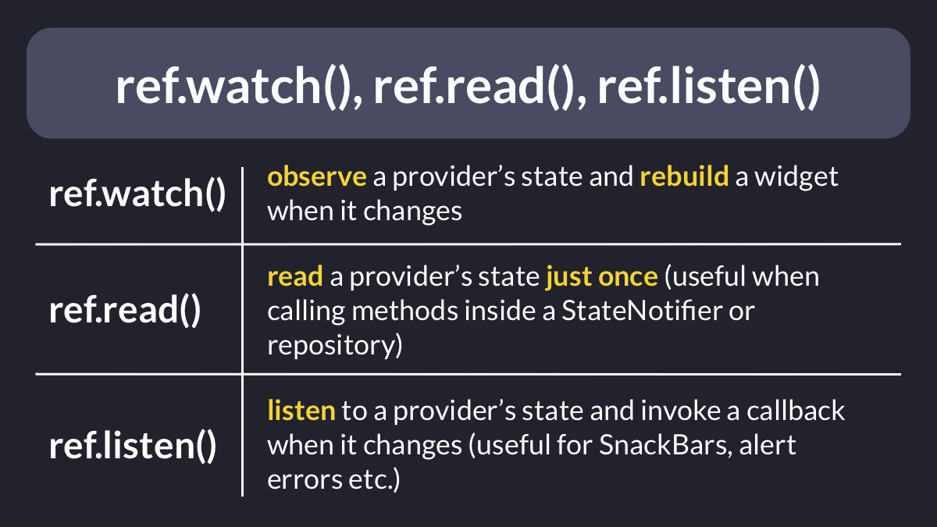

*class* SignInScreen *extends* ConsumerWidget {

const SignInScreen({Key? key}) : super(*key:* key);

@override

Widget build(BuildContext context, WidgetRef ref) {

// listening to state changes from StateNotifierProvider (i.e. signInScreenControllerProvider)

// (call a listener callback whenever the state changes) and

// showing errors if something goes wrong (with ref.listen)

ref.listen<AsyncValue> (

signInScreenControllerProvider, // provider

(_, state) => state.showSnackbarOnError(context), // listener with (prev, next) params and call the callback function when state changes

);

// watch and rebuild when the state changes (with ref.watch)

*final* AsyncValue<void> state = ref.watch(signInScreenControllerProvider);

return Scaffold(

*appBar:* AppBar(

*title:* const Text('Sign In'),

),

*body:* Center(

*child:* ElevatedButton(

// conditionally show a CircularProgressIndicator if the state is "loading"

*child:* state.isLoading

? const CircularProgressIndicator()

: const Text('Sign in anonymously'),

// disable the button if the state is loading

*onPressed:* state.isLoading

? null

// otherwise, get the notifier and sign in

// responding to user input by calling methods in the controller (with ref.read)

: () => ref

.read(signInScreenControllerProvider.notifier)

.signInAnonymously(),

),

),

);

}

}

To do that, we can define this AsyncValue **extension**:

*extension* AsyncValueUI *on* AsyncValue {

void showSnackbarOnError(BuildContext context) {

if (!isRefreshing && hasError) {

ScaffoldMessenger.of(context).showSnackBar(

SnackBar(*content:* Text(error.toString())),

);

}

}

}

**Put shared logic in Service**  
  
If you find yourself writing some logic that:

* depends on multiple data sources or repositories
* needs to be used (shared) by more than one widget

Then consider writing a **service class** for it.

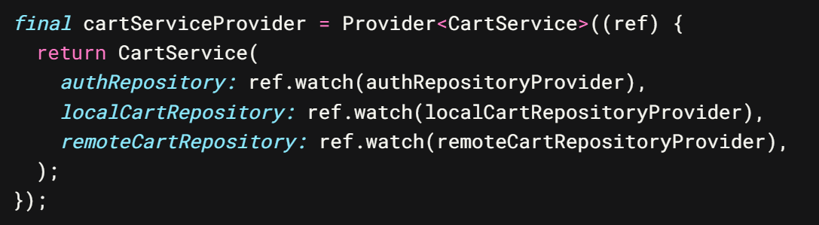

*final* cartServiceProvider = Provider<CartService>((ref) {

return CartService(ref);

});

*class* CartService {

CartService(this.ref);

*final* Ref ref;

/// fetch the cart from the local or remote repository

/// depending on the user auth state

Future<Cart> _fetchCart() {

*final* user = ref.read(authRepositoryProvider).currentUser;

if (user != null) {

return ref.read(remoteCartRepositoryProvider).fetchCart(user.uid);

} else {

return ref.read(localCartRepositoryProvider).fetchCart();

}

}

/// save the cart to the local or remote repository

/// depending on the user auth state

Future<void> _setCart(Cart cart) *async* {

*final* user = ref.read(authRepositoryProvider).currentUser;

if (user != null) {

*await* ref.read(remoteCartRepositoryProvider).setCart(user.uid, cart);

} else {

*await* ref.read(localCartRepositoryProvider).setCart(cart);

}

}

}

/// adds an item to the local or remote cart

/// depending on the user auth state

Future<void> addItem(Item item) *async* {

// 1. fetch the cart

*final* cart = *await* _fetchCart();

// 2. return a copy with the updated data

*final* updated = cart.addItem(item);

// 3. set the cart with the updated data

*await* _setCart(updated);

}

}

/// removes an item from the local or remote cart depending on the user auth

/// state

Future<void> removeItemById(String productId) *async* {

// business logic

*final* cart = *await* _fetchCart();

*final* updated = cart.removeItemById(productId);

*await* _setCart(updated);

}

/// sets an item in the local or remote cart depending on the user auth state

Future<void> setItem(Item item) *async* {

*final* cart = *await* _fetchCart();

*final* updated = cart.setItem(item);

*await* _setCart(updated);

}

}

## [Controller](https://codewithandrea.com/articles/flutter-app-architecture-application-layer/#implementing-the-shoppingcartitemcontroller)

*class* ShoppingCartItemController *extends* StateNotifier<AsyncValue<void>> {

ShoppingCartItemController({*required* this.cartService})

: super(const AsyncData(null));

*final* CartService cartService;

Future<void> updateQuantity(Item item, int quantity) *async* {

// set loading state

state = const AsyncLoading();

// create an updated Item with the new quantity

*final* updated = Item(*productId:* item.productId, *quantity:* quantity);

// use the cartService to update the cart

// and set the state again (data or error)

state = *await* AsyncValue.guard(

() => cartService.updateItemIfExists(updated),

);

}

Future<void> deleteItem(Item item) *async* {

state = const AsyncLoading();

state = *await* AsyncValue.guard(

() => cartService.removeItemById(item.productId),

);

}

}

[Provider](https://codewithandrea.com/articles/flutter-app-architecture-application-layer/#implementing-the-shoppingcartitemcontroller)

*final* shoppingCartItemControllerProvider =

StateNotifierProvider<ShoppingCartItemController, AsyncValue<void>>((ref) {

return ShoppingCartItemController(

*cartService:* ref.watch(cartServiceProvider),

);

});

[Controller](https://codewithandrea.com/articles/flutter-app-architecture-application-layer/#implementing-the-shoppingcartitemcontroller)

/// A product along with a quantity that can be added to an order/cart

*class* Item {

const Item({

*required* this.productId,

*required* this.quantity,

});

*final* ProductID productId;

*final* int quantity;

}

*class* Cart {

const Cart([this.items = const {}]);

/// All the items in the shopping cart, where:

/// - key: product ID

/// - value: quantity

*final* Map<ProductID, int> items;

/// Note: ProductID is just a String

}

/// Helper extension used to mutate the items in the shopping cart.

*extension* MutableCart *on* Cart {

// implementations omitted for brevity

Cart addItem(Item item) { ... }

Cart setItem(Item item) { ... }

Cart removeItemById(ProductID productId) { ... }

}

[Repositories](https://codewithandrea.com/articles/flutter-app-architecture-application-layer/#implementing-the-shoppingcartitemcontroller)  
*abstract* *class* AuthRepository {

/// returns null if the user is not signed in

AppUser? *get* currentUser;

/// useful to watch auth state changes in realtime

Stream<AppUser?> authStateChanges();

// other sign in methods

}

*abstract* *class* LocalCartRepository {

// get the cart value (read-once)

Future<Cart> fetchCart();

// get the cart value (realtime updates)

Stream<Cart> watchCart();

// set the cart value

Future<void> setCart(Cart cart);

}

*abstract* *class* RemoteCartRepository {

// get the cart value (read-once)

Future<Cart> fetchCart(String uid);

// get the cart value (realtime updates)

Stream<Cart> watchCart(String uid);

// set the cart value

Future<void> setCart(String uid, Cart items);

}

[Repositories providers](https://codewithandrea.com/articles/flutter-app-architecture-application-layer/#implementing-the-shoppingcartitemcontroller)

*final* authRepositoryProvider = Provider<AuthRepository>((ref) {

// This should be overridden in main file

throw UnimplementedError();

});

*final* localCartRepositoryProvider = Provider<LocalCartRepository>((ref) {

// This should be overridden in main file

throw UnimplementedError();

});

*final* remoteCartRepositoryProvider = Provider<RemoteCartRepository>((ref) {

// This should be overridden in main file

throw UnimplementedError();

});

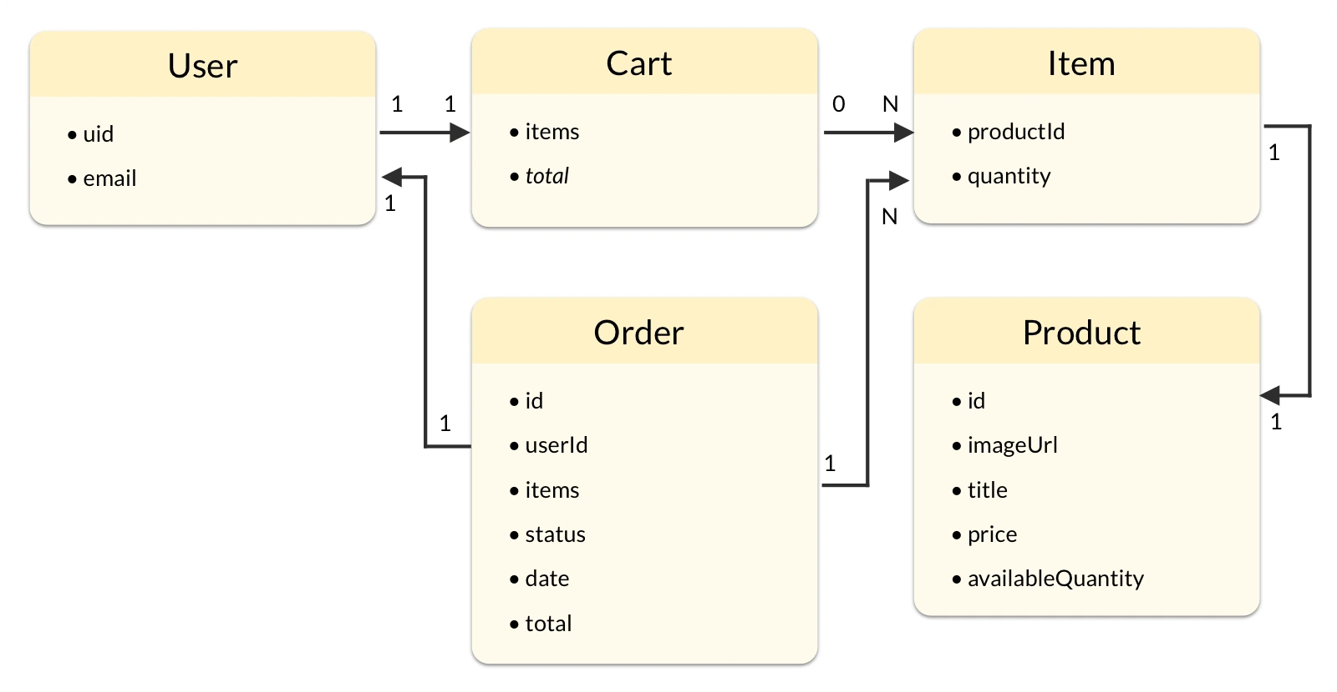

## The repository pattern

Repositories may not need an abstract class In general, creating an abstract class makes sense if you need many implementations that conform to the same interface. Chances are that you'll only need one implementation for a given repository, and you can define that as a single, concrete class.

For example, here's an abstract class that defines the **interface** for our repository:

*abstract* *class* WeatherRepository {

Future<Weather> getWeather({*required* String city});

}

import 'package:http/http.dart' as http;

*class* HttpWeatherRepository *implements* WeatherRepository {

HttpWeatherRepository({*required* this.api, *required* this.client});

// custom class defining all the API details

*final* OpenWeatherMapAPI api;

// client for making calls to the API

*final* http.Client client;

// implements the method in the abstract class

Future<Weather> getWeather({*required* String city}) {

// TODO: send request, parse response, return Weather object or throw error

}

}

once you've initialized your repository, you can access it anywhere else in your app (widgets, blocs, controllers, etc.).

 provider

import 'package:flutter_riverpod/flutter_riverpod.dart';

*final* weatherRepositoryProvider = Provider<WeatherRepository>((ref) {

return HttpWeatherRepository(*api:* OpenWeatherMapAPI(), *client:* http.Client());

});

**Update a Map of key-value pairs in Dart**Map.update() method

*class* ShoppingCart {

*final* Map<String, int> items = {};

void add(String key, int quantity) {

items.update(

key,

(value) => quantity + value,

*ifAbsent:* () => quantity,

);

}

}

**ref.listen**

For example, suppose you have a logout button which behaves like this: - When pressed, call a method to sign out - While sign out is in progress, disable the button - If an error occurs, show a SnackBar As a starting point, we can create our button as a ConsumerWidget:  
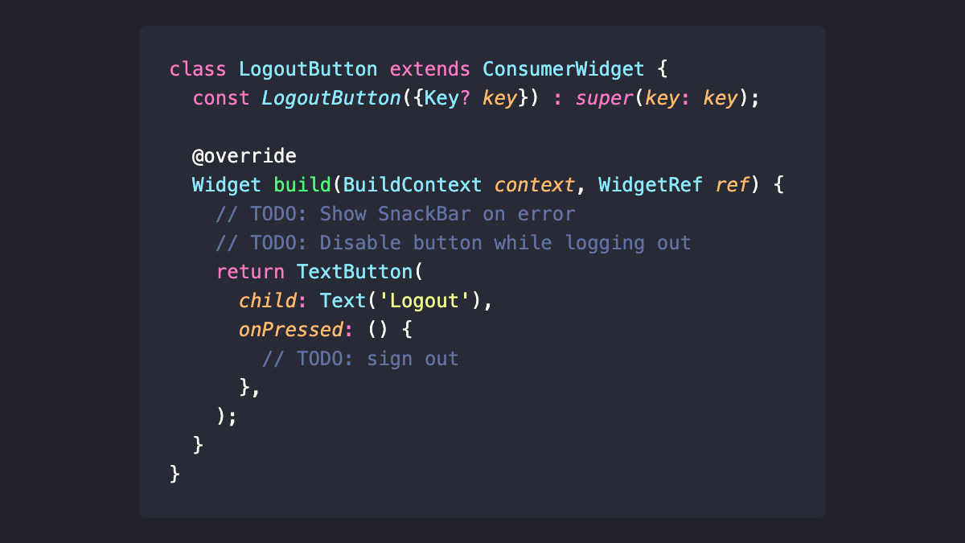

Next up, we can create a StateNotifier subclass for our button, along with the corresponding provider. Note the use of AsyncValue.guard(). This can be used as a lightweight alternative to try/catch as explained here:  
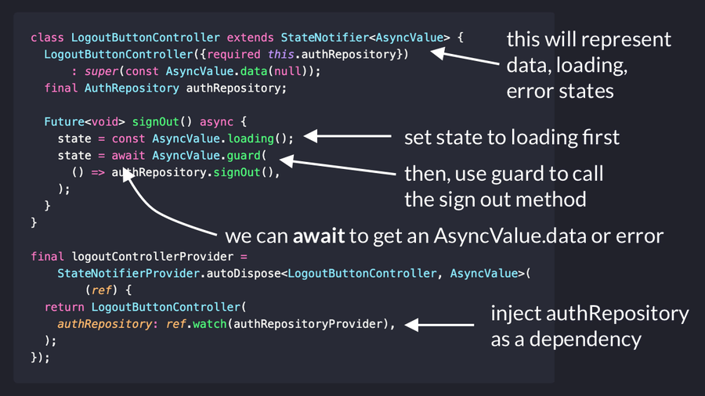

Next, let's use the notifier in our widget:   
- in the **build()** method, we can call **ref.watch()** to watch the provider's state and disable our button if it's "loading"   
- inside the callback, we use **ref.read()** so we can call methods in our notifier.

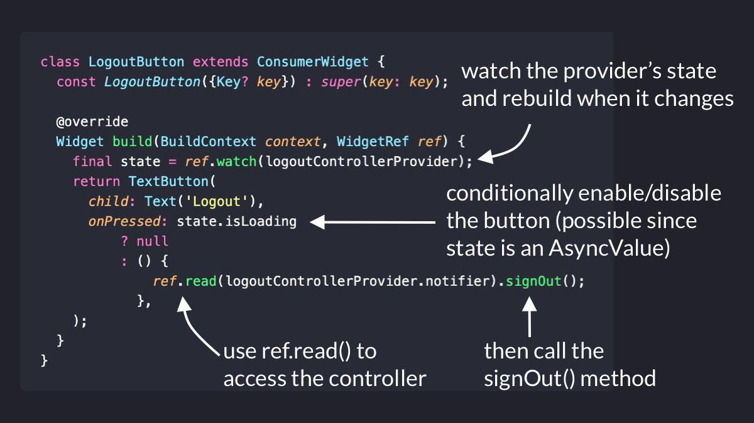

What about errors?   
We can use **ref.listen()** to trigger a callback every time the state changes.   
Inside it, we can check the previous and current state show a SnackBar on error.   
Note: As of Riverpod 2.0, you'll also want to check **state.isRefreshing**:

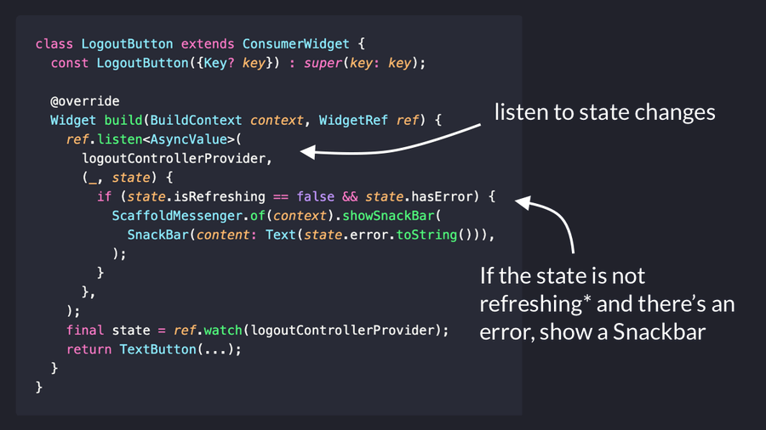

Lastly, note how we now have a good separation of concerns:   
- our StateNotifier manages the widget state and calls the signOut method in the auth repository   
- our widget watches state changes and shows the UI This makes our code more testable and maintainable in the long run.

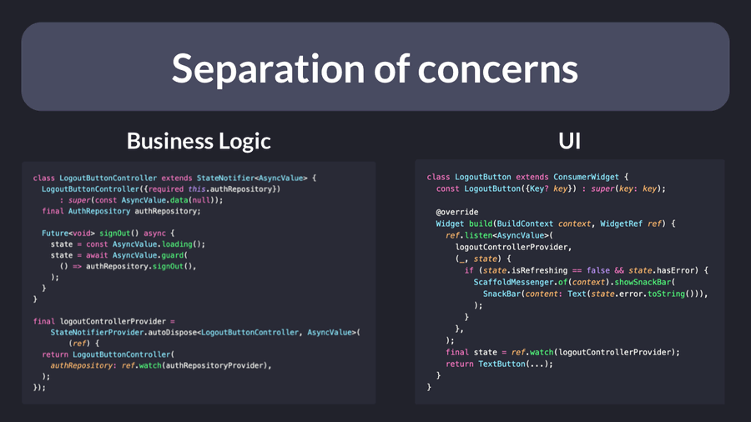

Freezed

 a code generator for immutable classes. Immutable classes are classes that don't change their properties and this feature is very good for state management and for use in data models.

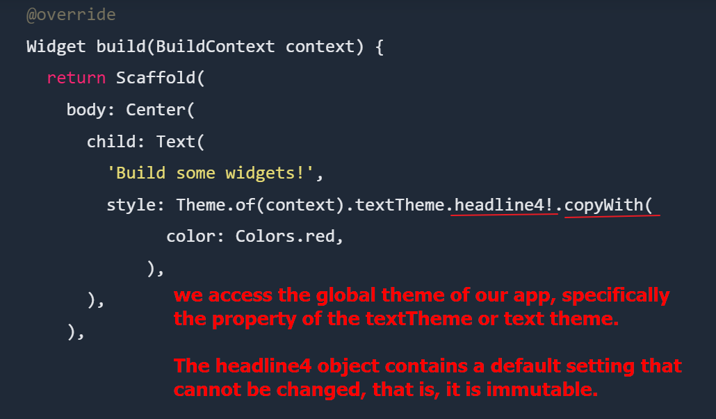

That's where the **copyWith** comes in. This method allows us to return an instance of the same class or an identical object to which we are applying the method, but with the possibility of changing one or more properties as we want.

In the previous example, it allows us to change the color of the **headline4** by means of**copyWith**.

Freezed

|  |  |
| --- | --- |
| **Before** | **After** |
| before | before |

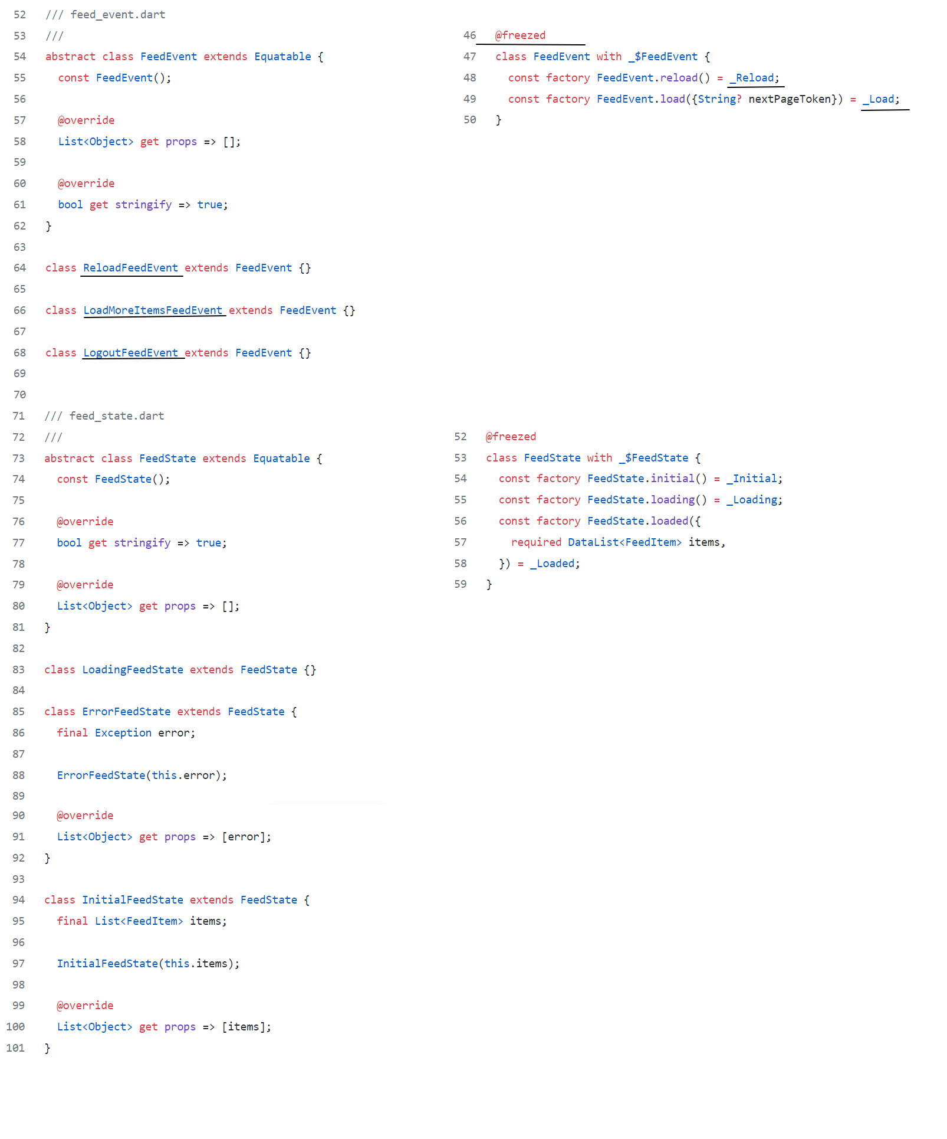

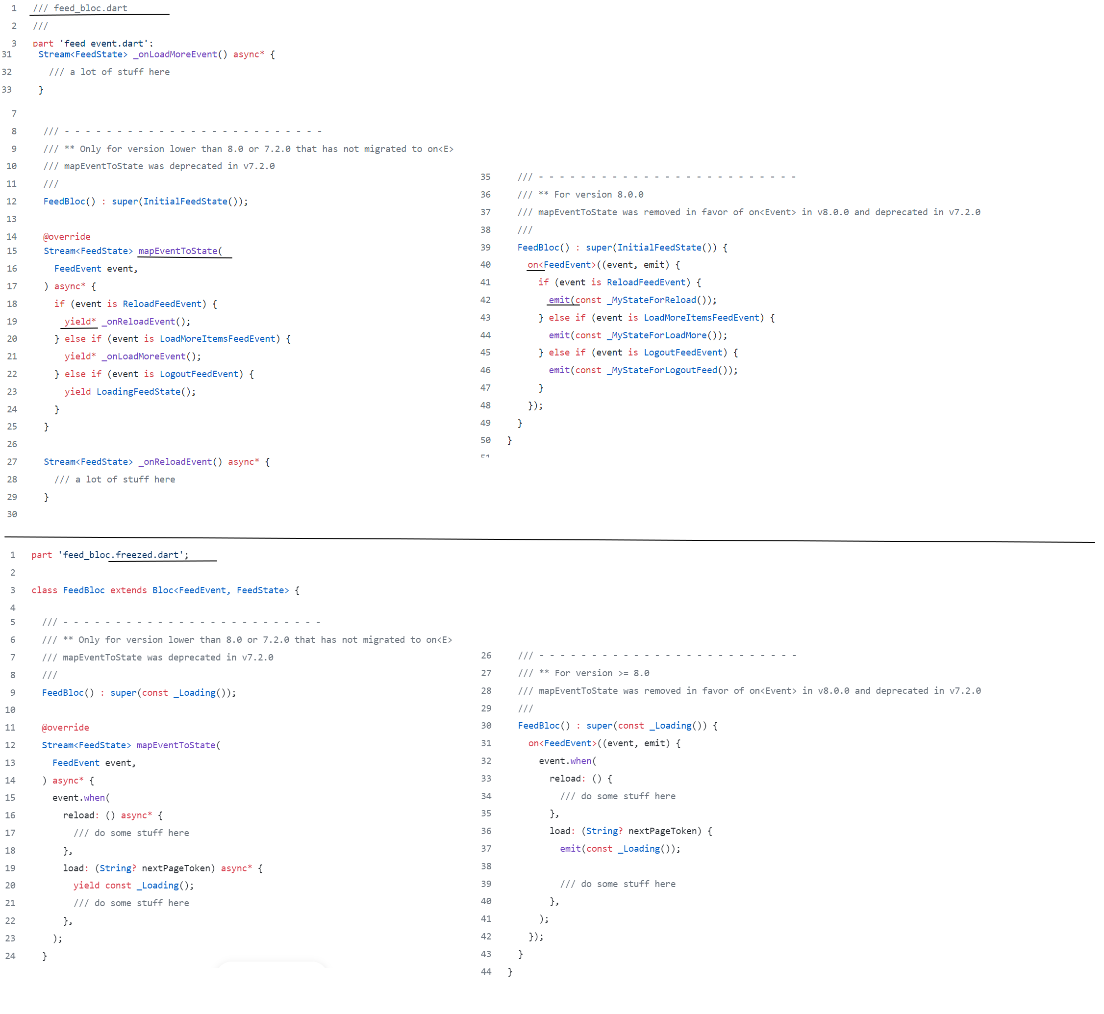

# **MVP architecture pattern**

The MVP divides an application into three layers: Model, View, and Presenter (Controller is replaced by the Presenter). In MVP, View and Presenter are completely decoupled and communicate each other by the interfaces.

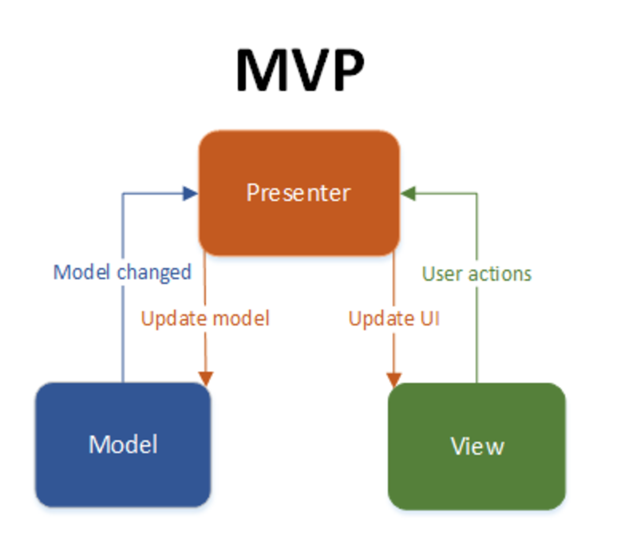 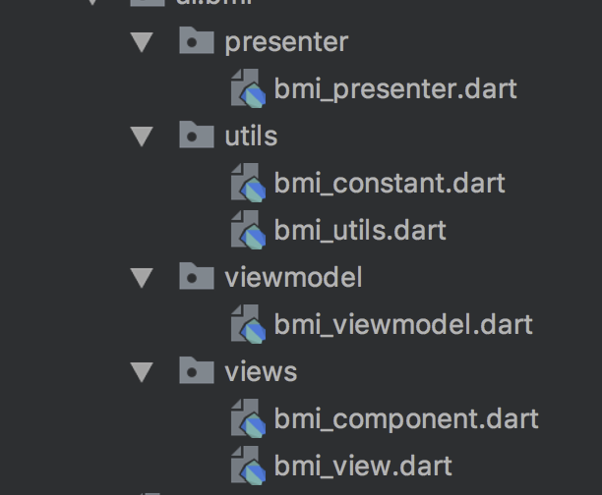

**Json**

To **send** JSON data over the network, it first needs to be **encoded** or **serialized**.   
**Encoding** **(.toJson)** is the process of turning a **data structure** into a **string**.   
  
The opposite process is called **decoding** or **deserialization (.fromJson)**. When you receive a JSON payload as a string, you need to **decode (as** Map<String, dynamic>) or **deserialize** it before you can use it.

Receive json with fromJson

// type: String

// json string

*final* jsonData = '{ "name": "Pizza da Mario", "cuisine": "Italian" }';

// type: dynamic (runtime type: _InternalLinkedHashMap<String, dynamic>)

// convert it to map

*final* parsedJson = jsonDecode(jsonData);

// type: Restaurant

// return a Restaurant object

*final* restaurant = Restaurant.fromJson(parsedJson);

Send json via network (toJson):

// given a Restaurant object

*final* restaurant = Restaurant(*name:* "Patatas Bravas", *cuisine:* "Spanish");

// convert it to map

*final* jsonMap = restaurant.toJson();

// encode it to a JSON string

*final* encodedJson = jsonEncode(jsonMap);

// then send it as a request body with any networking packag